Investigating the relationship between the investment strategies employed and the risk management practices followed by leading U.S. hedge funds

1 Introduction
One of the key players in the financial landscape has been hedge funds that employ a range of strategies to generate returns for their investors. According to the Hedge Fund Research (HFR) report, the hedge fund industry has grown substantially, managing more than $3.95 trillion in assets as of 2023 (“HFR Global Hedge Fund Industry Report | HFR®,” 2023b).
Leading U.S. hedge funds have demonstrated remarkably high levels of performance, often outpacing market indices. However, what is less clear is how these hedge funds consistently achieve such performance and what role their specific investment strategies and risk management tactics play. According to (Stoforos, Degiannakis, & Palaskas, 2017), there is a rising interest in understanding the driving factors behind hedge fund performance, especially in the aftermath of financial crises.
Several studies have sought to demystify the success of leading hedge funds. For example, (Fung & Hsieh, 2004a) investigated the risk and return profiles of hedge funds and found substantial variations across different strategies.
The 2008 financial crisis has further underlined the importance of effective risk management in investment decisions (Aloqab, Alobaidi, & Raweh, 2018).
Furthermore, globalization has expanded the reach of hedge funds, allowing them to invest in a myriad of financial instruments across the globe. This international exposure increases both the complexity and the risk factors associated with hedge fund investments. Consequently, the strategies that worked in domestic markets may not necessarily yield the same results internationally, making it imperative to reevaluate traditional investment strategies and risk metrics in the context of a global financial landscape (Torrance, 2009).
Technological advancements have also played a pivotal role in shaping the hedge fund industry. With the advent of machine learning algorithms and big data analytics, hedge funds are leveraging these tools to make more informed investment decisions (Huber, 2019a). However, this incorporation of technology also introduces new types of risks, such as data breaches and algorithmic errors, which have yet to be fully explored in existing literature.
In light of these complexities and challenges, this study aims to provide a comprehensive analysis that ties together the various threads of investment strategies, risk management practices, and performance outcomes specifically for leading U.S. hedge funds.
1.1 Problem Statement
Hedge funds have been the subject of significant academic and practical interest, yet there exists a notable gap in our understanding of the mechanisms that drive their success, particularly among leading U.S. hedge funds. This is a critical issue, given that the hedge fund industry is not only large but also highly influential in the global financial market.
The industry’s opaque nature, coupled with its complex financial instruments and strategies, makes it challenging for both investors and regulators to assess the risks and rewards accurately. (Fung & Hsieh, 2004b) argued that the complexity of hedge fund operations often obscures the link between investment strategies and performance, making it difficult for stakeholders to make informed decisions.
Moreover, the recent market volatility and economic uncertainties, such as those triggered by the COVID-19 pandemic, have magnified the need for effective risk management. As noted by (Hwang, Xu, In, & Kim, 2017), systemic risks associated with hedge funds could have a far-reaching impact on financial stability. Therefore, understanding the interplay between investment strategies, risk management, and performance becomes critical, not just for maximizing returns but also for safeguarding financial systems.
1.2 Objectives of the Study and Hypothesis
The primary objective of this study is to investigate the relationship between the investment strategies employed and the risk management practices followed by leading U.S. hedge funds, and how these factors correlate with their performance. The existing literature provides segmented insights into various facets such as risk metrics and investment strategies.
This aligns with studies that suggest the existence of specific strategies and risk metrics that are more likely to yield high returns, albeit with varying degrees of risk (JAGANNATHAN, MALAKHOV, & NOVIKOV, 2010).

1.3 Methodology Overview
To achieve the stated objectives and test the hypothesis, this study employs a quantitative research methodology. The use of quantitative methods aligns with the precedence set by other seminal works in hedge fund research, such as those by (Agarwal & Naik, 2000).
The study relies on secondary data gathered from reputable financial databases, specifically focusing on hedge funds based in the United States that are classified as leading performers by Hedge Fund Research (HFR). Given the importance of data quality, this study will exclusively use data provided by Hedge Fund Research (HFR). As a reputable source for hedge fund data, HFR's databases adhere to rigorous data collection standards and offer extensive data points, covering multiple years.
Once the data are gathered, they are processed and cleaned to eliminate outliers and anomalies that could skew the results. This step is critical for ensuring the validity of the study and follows best practices recommended by (Conlon, Ruskin, & Crane, 2007).
1.4 Disposition
The structure of this study is designed to provide a logical and comprehensive exploration of the factors affecting the performance of leading U.S. hedge funds, particularly focusing on their investment strategies and risk management practices.
- Introduction: The first chapter serves as the gateway to the research, introducing the problem statement, objectives, hypothesis, and methodology overview.
- Literature Review: Chapter two reviews existing literature on hedge funds, investment strategies, performance metrics, and risk metrics. This chapter aims to establish the theoretical foundation for the study and identify gaps in current research.
- Methodology: This chapter provides a discussion of the research methods employed in the study, covering aspects such as data collection, data processing, and statistical analysis.
- Data Analysis: Chapter four presents the empirical findings based on the data collected. It includes descriptive statistics, performance, and risk analysis, as well as correlation and regression analyses.
- Results: This chapter interprets the findings of the data analysis, drawing conclusions about the correlation between investment strategies, risk metrics, and performance levels of leading U.S. hedge funds.
2 Literature Review
The subject of hedge funds has been a focal point of financial studies for years, attracting interest from academics, investors, and regulators alike. Originating as exclusive investment pools for affluent individuals, hedge funds have evolved into complex financial institutions that employ a wide range of investment strategies to generate returns for their investors.
Initially designed to protect ('hedge') against market downturns, these funds have diversified into a range of complex financial instruments and strategies, extending their reach into equities, derivatives, currencies, and commodities (Bali, Brown, & Demirtas, 2013) This diversification is indicative of the industry's evolution and the increasing sophistication in strategies and risk management techniques employed by hedge funds.
Their investment activities can significantly impact asset prices, liquidity levels, and even the stability of the global financial system (Kruttli, Patton, & Ramadorai, 2015).
Another pivotal aspect that this review aims to address is the methodological approaches that have been employed in previous research on hedge funds. Given the complexity and diversity of hedge fund strategies, the methodologies used in their study must be robust and versatile. Over the years, researchers have employed a variety of quantitative methods, including regression analysis, time-series analysis, and more recently, machine learning techniques (Kruttli et al., 2015).
However, the use of these advanced methodologies is not without controversy. For instance, while machine learning techniques have proven useful in capturing the non-linear relationships in hedge fund returns, critics argue that these methods can be “overfit” to the data, thus reducing their predictive power (Huber, 2019b). This has led to debates within the academic community on the most appropriate methodologies for studying hedge funds, especially those that employ complex, non-linear strategies.
One of the most debated topics in hedge fund literature is the use of performance metrics. Traditional metrics like the Sharpe Ratio, Alpha, and Beta are commonly employed but have been critiqued for various limitations. For example, the Sharpe Ratio, which measures risk-adjusted returns, has been criticized for not adequately accounting for the non-normal distribution of hedge fund returns (Eling, 2008). Similarly, Alpha and Beta, which measure a fund’s performance relative to a benchmark, are often deemed insufficient for capturing the full scope of hedge fund strategies, which may include options, futures, and other complex derivatives (Ackermann, McEnally, & Ravenscraft, 1999).
In addition to performance metrics, another critical area of study is the risk metrics used to assess hedge fund strategies. Standard deviation, Value at Risk (VaR) are among the most widely-used metrics for assessing the risk profiles of hedge funds. However, these metrics too have their limitations and critics.
For example, Standard Deviation measures the average deviation of returns from the mean, but it assumes a normal distribution of returns, which is often not the case for hedge funds (Liang & Park, 2010). Value at Risk (VaR), another popular risk metric, provides an estimate of potential losses over a specific period at a given confidence level. However, VaR has been criticized for its inability to capture tail risks, or the risks of extreme financial events (Cuoco, He, & Isaenko, 2008).
While hedge funds are a global phenomenon, a significant amount of research has been disproportionately focused on funds based in the United States and Europe. The U.S., being a significant market for hedge funds, has been the subject of extensive studies. However, the industry is global, with rising markets in Asia and other parts of the world. The geographical focus in existing literature often overlooks the global nature of hedge funds, which could lead to a skewed understanding of the industry (Caglayan & Ulutas, 2014).
The potential systemic risks posed by hedge funds have become a topic of concern, especially after the 2008 financial crisis. Due to their significant leverage ratios and interconnectedness with other financial institutions, hedge funds are increasingly viewed as potential sources of systemic risks (Billio, Getmansky, Lo, & Pelizzon, 2010).
Several studies have called for more robust regulatory frameworks to monitor the systemic risks associated with hedge funds, including the implementation of stress tests similar to those required for banks (Chan, Getmansky, Haas, & Lo, 2005). These calls have led to some regulatory changes, but there is still ongoing debate on how best to mitigate these risks without stifling innovation and performance.
2.1 Hedge Funds
Hedge funds represent a unique segment of the investment landscape, distinguished by their flexible investment mandates and often sophisticated risk management techniques. Unlike traditional investment vehicles such as mutual funds, hedge funds are not subject to the same regulatory limitations and thus possess the latitude to engage in a wide array of investment strategies. These can range from equity trading to fixed income and even derivatives trading (Stulz, 2007).
Another distinguishing feature of hedge funds is their compensation structure. Typically, hedge fund managers are compensated based on both the assets under management (AUM) and the performance of the fund. This incentivizes fund managers to seek high returns, albeit sometimes at the cost of taking on higher risks (Goetzmann, Ingersoll, & Ross, 2003).
Investor access to hedge funds is generally more restricted compared to other investment vehicles. Hedge funds often require a significant initial investment, limiting their accessibility to institutional investors or high-net-worth individuals. This selectivity in investor base aligns with the higher risk profile of these funds (Agarwal, Nanda, & Ray, 2013).
2.2 Investment Strategies
Traditional investment vehicles constrained by regulatory guidelines, hedge funds have the flexibility to pursue a diverse range of investment strategies to generate both absolute and risk-adjusted returns.
One of the defining features of hedge funds is their ability to employ a multitude of investment strategies, which can vary significantly in complexity and risk profile (Ackermann et al., 1999).
The analytical approach to strategy formulation can also differ among hedge funds. Some funds rely primarily on quantitative models to guide their investment decisions. In contrast, others may adopt a more fundamental approach, analyzing financial statements, market trends, and economic indicators (Subhash & Enke, 2019).
Derivatives such as options and futures contracts are frequently used in hedge fund strategies to hedge risks or to speculate on future price movements. The use of derivatives adds another layer of complexity and risk to hedge fund operations, requiring sophisticated risk management techniques to mitigate potential losses (Chen, 2011).
Risk diversification is another crucial aspect of hedge fund strategies. Some funds may employ a multi-strategy approach to achieve diversification, combining various investment styles like long-short equity, event-driven, and fund of funds strategies within a single fund. This approach aims to achieve a more balanced risk-reward profile (Metzger & Shenai, 2019).
Short selling is another strategy often employed by hedge funds to profit from expected declines in asset prices. This strategy involves borrowing an asset and selling it in the market, with the aim of buying it back at a lower price in the future. While this strategy can be profitable, it is also fraught with risk, as losses can be theoretically infinite if the asset price increases instead of declining (Ben-David, Franzoni, & Moussawi, 2012).
2.2.1 Equity Hedge
The Equity Hedge strategy is one of the most commonly utilized approaches in the hedge fund universe. Fundamentally, it involves taking both long and short positions in equity markets to capitalize on upward and downward market movements, aiming for a market-neutral stance (Patton, 2009). By doing so, the strategy seeks to generate consistent returns while mitigating systemic market risk.
Equity hedge strategies can be further classified into various types, each with its unique characteristics. For example, market-neutral strategies aim to achieve zero market exposure by balancing long and short positions in a way that cancels out market risk. On the other hand, variable-bias strategies allow the hedge fund manager to adjust the net market exposure based on their market outlook, thereby introducing a directional element (Huang & Sun, 2018).
Equity hedge fund managers often employ a mix of fundamental and quantitative analysis to identify attractive long and short opportunities. While fundamental analysis focuses on assessing the intrinsic value of a company based on financial statements and macroeconomic indicators, quantitative models use statistical methods to predict price movements (Ma, 2022).
Risk management plays a crucial role in equity hedge strategies. Given that the strategy involves both long and short positions, it’s susceptible to both market risk and individual security risk. Various risk management techniques, such as portfolio rebalancing, are often used to manage these risks effectively (Brown, Goetzmann, Liang, & Schwarz, 2009).
Performance metrics like the Sharpe ratio and Alpha are frequently used to evaluate the effectiveness of equity hedge strategies. These metrics provide insights into the risk-adjusted returns of the strategy, allowing investors to compare it with other investment options (Getmansky, Lo, & Makarov, 2003).
2.2.2 Event Driven
Event-Driven strategies have carved a unique niche within the hedge fund landscape, focusing on exploiting investment opportunities arising from corporate events such as mergers, acquisitions, and restructurings (Choi & Lim, 2022). These strategies hinge on the fundamental premise that such events can trigger significant price movements in the stocks of the involved companies, providing ripe opportunities for substantial gains.
The Event-Driven space encompasses several sub-strategies, each with specific areas of focus. Merger arbitrage is one of the most prevalent, targeting gains from the price spread between the acquiring and target companies in the wake of a merger announcement. Similarly, distressed securities focus on companies facing financial difficulties, aiming to capitalize on the discounted prices of their debt or equity (Subhash & Enke, 2019).
Event-Driven strategies are generally research-intensive and require specialized expertise in financial analysis and corporate law. Managers often have to sift through complex legal documents and financial reports to ascertain the likelihood and potential impact of the anticipated corporate events (BRAV, JIANG, PARTNOY, & THOMAS, 2008).
The risk profile of Event-Driven strategies can be substantially different from other hedge fund strategies. A significant risk stems from the event not occurring as anticipated, leading to adverse price movements. Regulatory hurdles and changes in market sentiment are other notable risk factors that can impede the successful execution of these strategies (BOYSON, STAHEL, & Stulz, 2010).
Performance evaluation in Event-Driven strategies often employs metrics like the Information Ratio to measure the risk-adjusted returns and the potential loss in adverse scenarios, respectively. These metrics are crucial in gauging the effectiveness of the strategy in achieving its investment objectives (Ben-David et al., 2012).
2.2.3 Fund of Funds
Fund of Funds (FoF) strategies represent a distinctive segment in the hedge fund arena, concentrating on diversification by investing in multiple hedge funds rather than direct assets. This approach is designed to offer investors a broad exposure to a variety of investment styles and strategies, thus aiming to reduce risk through diversification.
Fund of Funds strategies can be primarily divided into two categories: diversified and niche. Diversified FoFs invest in a wide range of hedge funds spanning various strategies and styles, while niche FoFs focus on specific sectors or strategies, such as emerging markets or long-short equity.
A primary advantage of FoFs is the inherent diversification they provide. By allocating capital across multiple hedge funds, investors can mitigate the idiosyncratic risk associated with any single fund. This diversification can enhance the risk-adjusted return profile for investors (Hutchinson, Nguyen, & Mulcahy, 2022).
An essential aspect of FoF management is the rigorous due diligence process. Fund managers must carefully evaluate and select underlying hedge funds based on their performance track records, management expertise, and risk management practices. The capability to identify and invest in top-performing hedge funds is crucial for the success of a FoF strategy.
A notable characteristic of FoFs is the layered fee structure. Investors typically pay a fee to the FoF manager and additional fees to the underlying hedge funds. While this can result in higher total fees, proponents argue that the benefits of diversification and professional selection justify the costs.
Given the nature of their investments, FoFs often employ metrics such as the Sharpe Ratio to gauge risk-adjusted performance. Additionally, metrics like the Information Ratio can be used to assess the selection skill of the FoF manager in choosing underlying hedge funds (Subhash & Enke, 2019).
2.2.4 Relative Value
Relative Value strategies form an integral part of the hedge fund world, aiming to capitalize on price differentials between related financial instruments. These strategies seek to benefit from the relative mispricing of assets that are either identical or possess similar characteristics.
The most common types of Relative Value strategies include pairs trading, convertible arbitrage, and fixed-income arbitrage. Pairs trading involves taking a long position in one asset while simultaneously taking a short position in a related asset. The objective is to benefit from the convergence of their prices. Convertible arbitrage focuses on exploiting price differentials between a company's convertible bonds and its underlying stock (Ma, 2022).
Executing Relative Value strategies effectively requires a nuanced understanding of market mechanics and financial instruments. This is because even minor misjudgments can result in significant losses due to the leveraged nature of these strategies.
The risk profile in Relative Value strategies is unique. Although these strategies aim for market neutrality, they can still be affected by liquidity constraints, transaction costs, and changes in market conditions. Due diligence and robust risk management are essential to mitigate these risks.
Performance evaluation for Relative Value strategies often involves metrics like the Sharpe Ratio and Alpha. These metrics help in understanding the risk-adjusted returns and the strategy's ability to generate excess returns over a benchmark (Eling, 2008).
2.3 Performance Metrics
Evaluating the performance of hedge funds is a complex task that requires a comprehensive set of metrics. These metrics serve as tools for investors to assess the risk-adjusted returns and overall effectiveness of various investment strategies (missing citation).
Performance metrics are vital for multiple stakeholders, including fund managers, investors, and regulators. For fund managers, these metrics are crucial for assessing the effectiveness of their strategies and making necessary adjustments. Investors use these metrics to decide on fund allocations and to gauge the level of risk involved. Regulators, on the other hand, rely on these metrics to ensure market stability and investor protection (King & van Vuuren, 2016).
While there are numerous performance metrics, a few are commonly employed across the industry. These include the Sharpe Ratio, Alpha, Beta, and the Information Ratio. Each of these metrics offers a unique insight into various aspects of hedge fund performance:
- Sharpe Ratio: Measures the risk-adjusted returns of a hedge fund.
- Alpha: Indicates the fund's ability to outperform the market.
- Beta: Reflects the fund’s sensitivity to market movements.
- Information Ratio: Evaluates the excess return per unit of risk taken.
Performance metrics are not without their limitations. The use of historical data for these metrics, for instance, may not be indicative of future performance. Additionally, these metrics often ignore external factors like market liquidity and transaction costs, which could significantly affect hedge fund returns (Fung & Hsieh, 2004a).
Investor behavior is strongly influenced by performance metrics. High Sharpe ratios or Alphas often attract more investments, while low values might result in capital withdrawals. This behavior underscores the importance of maintaining robust performance metrics for long-term fund sustainability (Eling, 2008).
One of the advantages of utilizing standardized performance metrics is the ability to compare different hedge funds objectively. However, it's worth mentioning that while these metrics allow for some level of comparability, they don't account for the uniqueness of each hedge fund's strategy. Therefore, a careful interpretation of these metrics is needed when comparing hedge funds that operate under different strategies (Ackermann et al., 1999).
Given the importance of these metrics, various industry benchmarks have been established to provide context to the numbers.
While performance metrics focus primarily on returns, they are often studied in conjunction with risk metrics. This integrated approach allows for a more comprehensive view of the hedge fund's performance, balancing both reward and risk (missing citation).
2.3.1 Sharpe Ratio
The Sharpe Ratio, formulated by Nobel Laureate William F. Sharpe, is one of the most widely used performance metrics in the finance industry. The ratio measures the risk-adjusted return of an investment, essentially comparing the average return earned above the risk-free rate to the investment's volatility. The Sharpe Ratio serves as an intuitive metric that quantifies how much additional return an investor can expect for taking on extra risk (Klein, Purdy, Schweigert, & Vedrashko, 2015).
In the realm of hedge funds, the Sharpe Ratio is particularly relevant. Hedge funds often engage in high-risk strategies, making risk-adjusted returns a critical measure for investors. The ratio aids in standardizing the returns, thereby making it easier to compare funds with different risk profiles.
While the Sharpe Ratio is highly useful, it is not without limitations. For instance, it assumes that the returns are normally distributed, which is often not the case in hedge fund investments. Moreover, it is sensitive to outliers, and any extreme returns can skew the ratio, presenting a distorted view of the fund’s risk profile (Bollen, Joenväärä, & Kauppila, 2021).
The Sharpe Ratio is often juxtaposed with other performance metrics like Alpha and Beta. Although these metrics also offer valuable insights, the Sharpe Ratio is more comprehensive as it considers both return and volatility. However, a reliance solely on the Sharpe Ratio can be misleading, and it is often recommended to use it in conjunction with other metrics for a more holistic view (Bollen et al., 2021).
2.3.2 Alpha and Beta
Alpha and Beta are two other crucial metrics commonly employed for assessing the performance and risk of hedge funds. These measures provide a more nuanced understanding of a fund's behavior compared to a benchmark and the market as a whole (Fung & Hsieh, 2004a).
Alpha is an essential metric in performance evaluation, representing the excess return that a fund generates over its benchmark. It essentially measures the skill of the fund manager in generating returns irrespective of market conditions. In the context of hedge funds, Alpha can be a pivotal point of differentiation, as these funds often claim to offer non-correlated, superior returns. An Alpha greater than zero indicates that the fund has outperformed its benchmark, often attributed to the manager's skill.
Beta measures the sensitivity of the fund’s returns to those of the market. A Beta of 1 indicates that the fund moves in sync with the market. A Beta greater than 1 suggests higher volatility, while a Beta less than 1 indicates lower volatility relative to the market. Hedge funds often have varying Beta values depending on their investment strategies, providing a useful lens to gauge market risk (COŞKUN & ZOR, 2022).
While Alpha and Beta are powerful tools, they are not without flaws. Alpha is often criticized for being overly reliant on the chosen benchmark, which can be arbitrary. Moreover, Beta assumes a constant relationship with the market, which is seldom the case in dynamic hedge fund strategies (Fischer, Hanauer, & Heigermoser, 2016).
2.3.3 Information Ratio
The Information Ratio is another vital metric for evaluating hedge fund performance, closely related to the Sharpe Ratio but with some distinct features. It measures the excess return of a fund over its benchmark, adjusted for the tracking error. The tracking error is essentially the standard deviation of the excess returns, providing a measure of the risk taken to achieve those returns (missing citation).
The Information Ratio is calculated as the difference between the fund's return and the benchmark return, divided by the tracking error. In this way, it offers a more nuanced evaluation than the Sharpe Ratio, which uses the risk-free rate as a denominator. Hedge fund managers often aim for a high Information Ratio, as it showcases their ability to generate excess returns consistently while accounting for risk.
A higher Information Ratio indicates that the hedge fund has successfully outperformed its benchmark with a lower level of risk. The Information Ratio has been extensively used in the industry for performance attribution and is considered a reliable metric for differentiating skill from luck (Fung & Hsieh, 2004a).
The Information Ratio gains its real utility when used in the context of active portfolio management. It helps investors understand the value that the manager adds to the fund, over and above the benchmark. It is often used in conjunction with Alpha and Beta to offer a more holistic view of performance.
However, similar to other performance metrics, the Information Ratio is not without its limitations. It assumes a normal distribution of returns, which may not always be the case for hedge funds with complex strategies. Furthermore, the choice of benchmark can significantly impact the ratio, making it sensitive to the benchmark selection (Eling, 2008).
2.4 Risk Metrics
Understanding risk is as crucial as evaluating returns in the complex world of hedge funds. Risk metrics are the quantitative measures that provide a comprehensive view of the risk profile of an investment portfolio. These metrics help investors and fund managers make informed decisions and are essential in the realm of hedge funds, which often employ complex strategies that introduce various types of risk (Chincarini, 2014).
Risk metrics are vital for various stakeholders, including institutional investors, fund managers, and regulators. Institutional investors rely on these metrics to identify hedge funds that align with their risk tolerance levels, while fund managers use them to fine-tune their investment strategies. Regulators, such as the SEC, also employ these metrics to ensure that hedge funds operate within the defined risk parameters (Brown et al., 2009).
Hedge funds are exposed to various kinds of risks, including market risk, credit risk, operational risk, and liquidity risk. Each of these risks requires distinct metrics for accurate measurement and management (Fung & Hsieh, 2004b). For instance, market risk is typically assessed using Value at Risk (VaR) or Standard Deviation.
One of the significant challenges in risk assessment for hedge funds is the nonlinear relationships between different types of risks. While traditional metrics like Standard Deviation may provide insights into volatility, they are often inadequate for capturing extreme events like market crashes (missing citation).
Asset allocation is another area where risk metrics play a pivotal role. Investors often use these metrics to diversify their portfolios efficiently, aiming to achieve the highest possible return for a given level of risk. The accurate measurement and interpretation of risk metrics are therefore crucial in determining optimal asset allocation, further highlighting their importance in investment decision-making (Patel, 2022).
Despite their importance, risk metrics are not without limitations. They often rely on historical data, which may not always be indicative of future risk. Additionally, the quantification of risk can sometimes create a false sense of security, leading to underestimation of "tail risks" or extreme market events. Therefore, ongoing research and development are needed to create more robust, predictive risk metrics (Cao, Goldie, Liang, & Petrasek, 2016).
2.4.1 Standard Deviation
Standard deviation is a cornerstone metric in the realm of risk management and investment analysis, often regarded as the most straightforward and widely-used measure of risk. It quantifies the dispersion or volatility around an investment's average return, providing a gauge for the investment’s unpredictability. A higher standard deviation suggests a higher potential for volatility and therefore a higher level of risk. (missing citation).
The seminal work by Markowitz (1952) in Modern Portfolio Theory posited that investors are not merely concerned with expected returns but also the risks associated with them. Standard deviation came to be viewed as a key determinant of an asset's total risk. His work is foundational to the understanding that investors can benefit from diversification, as the standard deviation of a portfolio of assets is not simply the weighted average of the standard deviations of the individual assets but is influenced by the correlation coefficients among the assets (missing citation).
While the use of standard deviation as a risk metric has gained widespread acceptance, it is not without its critics. For instance, it assumes that asset returns are normally distributed, an assumption often violated in financial markets. Additionally, standard deviation treats all deviations from the mean—whether positive or negative—as equally undesirable, which is inconsistent with the general investor preference for higher returns (Liang & Park, 2010).
The application of standard deviation is not just limited to traditional assets like equities and bonds; it has also been applied to hedge funds. However, it's worth noting that hedge funds often engage in non-linear strategies that make the interpretation of their standard deviation quite complex (Huber, 2019b).
2.4.2 Value at Risk
Value at Risk (VaR) is another seminal risk metric that has gained prominence in the financial sector, particularly for its utility in risk management and regulatory capital calculations. Developed in the early 1990s, VaR aims to provide a single, summary statistic that captures the maximum potential loss an investment portfolio could face over a specified period for a given confidence interval (Fatouros et al., 2023).
VaR's introduction was groundbreaking because it could be applied across various asset classes, enabling a unified risk assessment for diversified portfolios. This universality gave financial institutions a more holistic understanding of risk, thus influencing capital allocation and investment decisions (missing citation).
However, VaR has been subject to criticisms. A primary concern is that it only measures the risk up to a certain confidence level and ignores what could happen beyond that point, often referred to as "tail risk". In other words, VaR may not fully capture the risk of extreme market events, which are rare but highly consequential (Liang & Park, 2007).
VaR's use in hedge funds is somewhat nuanced. These investment vehicles often engage in complex trading strategies that may not conform to the statistical assumptions underlying traditional VaR models. Therefore, extensions of the basic VaR concept, such as Conditional VaR (CVaR), have been developed to better capture the risk profile of hedge funds.
Despite its limitations, VaR continues to be a key risk metric used by institutional investors and financial regulators alike. It is often used in conjunction with other risk metrics like standard deviation and beta to provide a more comprehensive risk profile (Liang & Park, 2007).
3 Methodology
The methodology serves as the blueprint for this research project. It outlines the research design, data sources, sampling techniques, and analytical methods that will guide this investigation (missing citation).This section aims to provide a full-bodied explanation of how the research questions will be answered, ensuring that the results are reliable, valid, and generalizable to a larger population of interest.
This study employs a quantitative approach, using empirical methods to test hypotheses formulated in the introduction. A cross-sectional design is chosen to analyze data at a single point in time, offering a snapshot view of the relationship between hedge fund performance and investment strategies (Stoforos et al., 2017).
Given the study’s aim to test a specific set of hypotheses through measurable variables, a quantitative approach is deemed most appropriate. This method allows for a more objective evaluation of the investment strategies and performance metrics of hedge funds (Getmansky et al., 2003).
The primary source of data is the Hedge Fund Research (HFR) database, which provides comprehensive information on the performance, strategies, and risk metrics of U.S. hedge funds.
The HFR database is selected for its reputation for accuracy and comprehensiveness (“Database | HFR®,” 2023a).
A purposive sampling technique is used to select hedge funds based on predefined criteria, including a minimum AUM of $100 million and at least a ten-year track record. This ensures the inclusion of established, significant players in the hedge fund industry.
The purposive sampling technique allows for a focused study of funds that have demonstrated resilience and success over time, thereby increasing the likelihood of obtaining meaningful insights (missing citation).
Data collection is a pivotal aspect of any research project. In this study, data is primarily sourced from databases like HFR. Information is downloaded in CSV format for ease of manipulation and analysis. These databases provide monthly data points on returns.
Data processing methods are meticulously designed to ensure that the data is accurate, reliable, and ready for analysis. Data cleaning is essential to remove any anomalies that could affect the study's outcomes. Normalization ensures comparability across variables, which is critical for the validity of the statistical tests employed (Subhash & Enke, 2019).
The research hypotheses are formulated based on the literature review and are designed to be tested empirically. The primary hypothesis posits that "The high-performance levels of leading U.S. hedge funds are directly correlated with their investment strategies and risk indicators".
By employing a rigorous methodology, this study aims to produce meaningful insights into the relationships between hedge fund performance, investment strategies, and risk metrics.
No research methodology is without limitations. The primary limitation in this study is the availability and comprehensiveness of the data. Although databases like HFR is a rich source, it may not capture all hedge funds or every aspect of hedge fund performance and risk. This can result in selection bias, which could potentially impact the generalizability of the findings(missing citation).
3.1 Data Collection
The foundation of any quantitative research lies in its data collection methodology. For this study, which aims to investigate the performance and risk metrics of leading U.S. hedge funds, data collection assumes a pivotal role. The source of the data is singularly focused on the Hedge Fund Research (HFR) database, which aligns with the study's requirement to use primary investment strategies and risk metrics according to HFR.
Given the aim of assessing a comprehensive performance and risk profile, the data will span a decade from 2013 to 2023. The frequency of the data is set at a monthly interval to capture the intricacies and nuances that quarterly or yearly data might miss, allowing for a more robust analysis.
3.2 Data Processing
Once the data is collected from the HFR database, the subsequent step is the data processing phase. This segment is instrumental in ensuring that the raw data is converted into a format that is suitable for analysis. This section will elucidate the methods and tools utilized for data processing, including data cleaning, data transformation, and statistical tools employed for the study.
The initial step in data processing is cleaning the raw data. This involves identifying and rectifying errors and inconsistencies to improve its quality and reliability.
Once the data is cleaned, it undergoes transformation. The transformation process includes normalization and scaling to ensure that the data variables are comparable. For instance, if the variables are in different units, they are transformed to a common unit for ease of analysis missing citation.
Statistical analyses will be performed using software like Excel and Python. These tools are selected for their robustness and the broad array of statistical tests.
Before proceeding to data analysis, it's crucial to validate the processed data. This often involves a series of statistical tests to ensure that the data meets the assumptions of normality, linearity, and homoscedasticity (Fung & Hsieh, 2004a).
3.3 Research Hypothesis
Main Hypothesis: The high-performance levels of leading U.S. hedge funds are directly correlated with their investment strategies and risk indicators.
To make this main hypothesis empirically testable, it's broken down into several sub-hypotheses, each zeroing in on a different aspect of investment strategy or risk metrics.
Sub-Hypothesis 1: Equity Hedge Strategy and Performance
H1: Hedge funds employing an equity hedge strategy will significantly outperform those that do not.
This sub-hypothesis stems from earlier works indicating better risk-adjusted performance for equity hedge strategies. The focus here is to evaluate if the performance superiority is broad-based or particular to specific market conditions.
Sub-Hypothesis 2: Event-Driven Strategies and Risk
H2: Hedge funds using event-driven strategies will show lower Value at Risk (VaR) metrics compared to others.
Event-driven strategies, by their nature, capitalize on specific events that are less influenced by market trends. Thus, they are assumed to provide a hedging mechanism against market volatility (Capocci, Corhay, & Hubner, 2003).
Sub-Hypothesis 3: Sharpe Ratio as a Performance Predictor
H3: The Sharpe Ratio is a significant predictor of the overall performance of hedge funds.
The Sharpe Ratio measures the risk-adjusted return, making it a comprehensive metric for assessing hedge fund performance. Multiple empirical studies have confirmed its reliability as a performance indicator (Eling, 2008).
Sub-Hypothesis 4: Role of Standard Deviation
H4: A higher standard deviation in hedge fund returns is negatively correlated with fund performance.
Standard deviation measures the volatility of a fund's returns. Classic financial theory suggests that higher volatility typically correlates with lower returns, hence this sub-hypothesis (Fung & Hsieh, 2004a).
4. Data Analysis
4.1 Descriptive Statistics
Descriptive statistics serves as our compass, guiding us through a quantitative exploration of these strategies and their performance outcomes.
4.1.1 Diversity of Hedge Fund Strategies
At the heart of hedge funds lies the strategies they employ. Our dataset encapsulates four predominant strategies:
- Equity Hedge: A strategy that oscillates between long and short positions in equities, aiming to exploit market inefficiencies while hedging against potential downturns.
- Event-Driven: This approach centers on anticipated corporate events such as mergers, divestitures, or other structural shifts, with the goal of reaping benefits from price adjustments.
- Fund of Funds: A meta-strategy of sorts, it pools investments across a portfolio of multiple hedge funds, aiming to harness the power of diversification.
- Relative Value: This strategy thrives on price discrepancies between related financial instruments, seeking to capitalize on these temporary mispricings.
4.1.2 Dissecting Returns: A Visual Exploration
Visual representations often transcend the limitations of numbers, offering a more intuitive grasp of data. In Figure 2, we present a histogram showcasing the distribution of returns for each strategy.
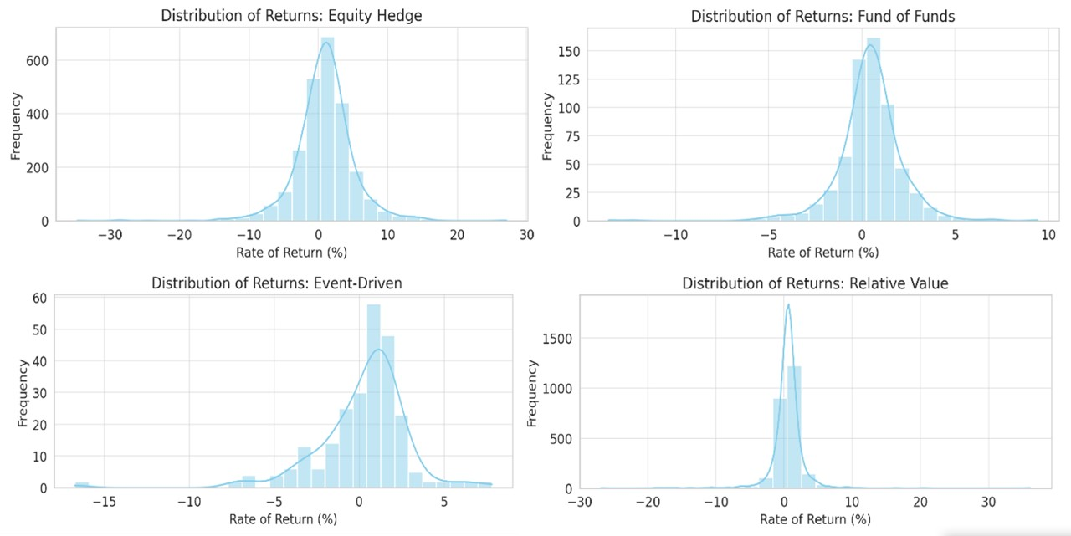
Figure 2: Distribution of Returns by Hedge Fund Strategy
The histograms in Figure 2 illustrate the distribution of returns for each hedge fund strategy. Several observations emerge:
- Equity Hedge funds exhibit a relatively symmetrical distribution, hinting at a balanced performance profile. The peak around the 0% mark suggests frequent occurrences of near-neutral returns, which might be a result of successful hedging operations.
- Event-Driven funds show a positive skew, with a higher density of returns on the right side of the histogram. This indicates more frequent positive returns compared to negative ones, emphasizing the strategy's potential success in capitalizing on corporate events.
- Fund of Funds demonstrates a peak around the median, with fewer extreme performances on either side. This distribution underscores the strategy's conservative nature, aiming for consistent, moderate returns.
- Relative Value funds portray a narrower spread, highlighting the strategy's volatile nature. The presence of returns on both extremes suggests that while many funds successfully exploit price differentials, some might face challenges.
4.1.3 Descriptive Metrics Across Strategies
To translate our visual observations into quantifiable insights, let's delve into the descriptive metrics. The table below encapsulates the essence of hedge fund performance across strategies:
Table 2: Descriptive Metrics of Returns by Strategy
Strategy | Mean Return | Median Return | Min Return | Max Return
Equity Hedge | 0.91% | 1.00% | -34.72% | 27.07%
Event-Driven | 0.78% | 0.57% | -30.24% | 21.50%
Fund of Funds | 0.41% | 0.45% | -13.58% | 9.42%
Relative Value | 0.52% | 0.58% | -26.86% | 36.10%

- Equity Hedge funds, with the highest mean return, resonate with the potential of this strategy to exploit stock mispricings. however, the broad gap between its minimum and maximum returns suggests considerable volatility, emphasizing the risk-reward dynamic intrinsic to this strategy.
- Event-Driven funds showcase a mean return slightly below that of Equity Hedge funds. The narrower range between the minimum and maximum returns underscores the strategy's focus on specific corporate events, which, while offering significant upside, can also pose risks if the anticipated events don't materialize.
- Fund of Funds, with the most conservative profile, mirrors its inherent philosophy of risk diversification. By pooling investments across various hedge funds, it aims to harness the benefits of diversification, leading to a more stable return profile.
- Relative Value funds, while competitive in terms of median returns, display a wide range of performances. This is reflective of the challenges in consistently capitalizing on price differentials between related instruments.
4.2.1 Analysis of Performance Metrics
In the realm of hedge fund performance analysis, various metrics provide insights into the efficiency and efficacy of a fund's strategy. Among the most commonly employed are the Sharpe Ratio, Alpha, and Beta, as well as the Information Ratio. Each of these metrics offers a unique perspective on the fund's performance, helping investors determine the attractiveness of a hedge fund in the context of risk and return. In this section, we will delve deep into the computation and interpretation of these metrics using the data at hand.
Sharpe Ratio
The Sharpe Ratio is a widely recognized metric that gauges the risk-adjusted performance of an investment. It is calculated using the formula:

For our analysis, we assume a risk-free rate of 0.03% (a typical short-term treasury bill rate), though in a real-world scenario, this might vary based on the specific timeframe or economic conditions.
The table above displays the average monthly rate of return for each fund and the benchmark (Benchmark HFRI NA Index). This average rate of return provides an indication of the typical monthly performance for each fund over the period covered by our data.
For instance, the 'ACK Asset Partners LP' has an average monthly return of approximately 1.06384%, whereas the benchmark index 'Benchmark HFRI NA Index' has an average of 0.46736%.
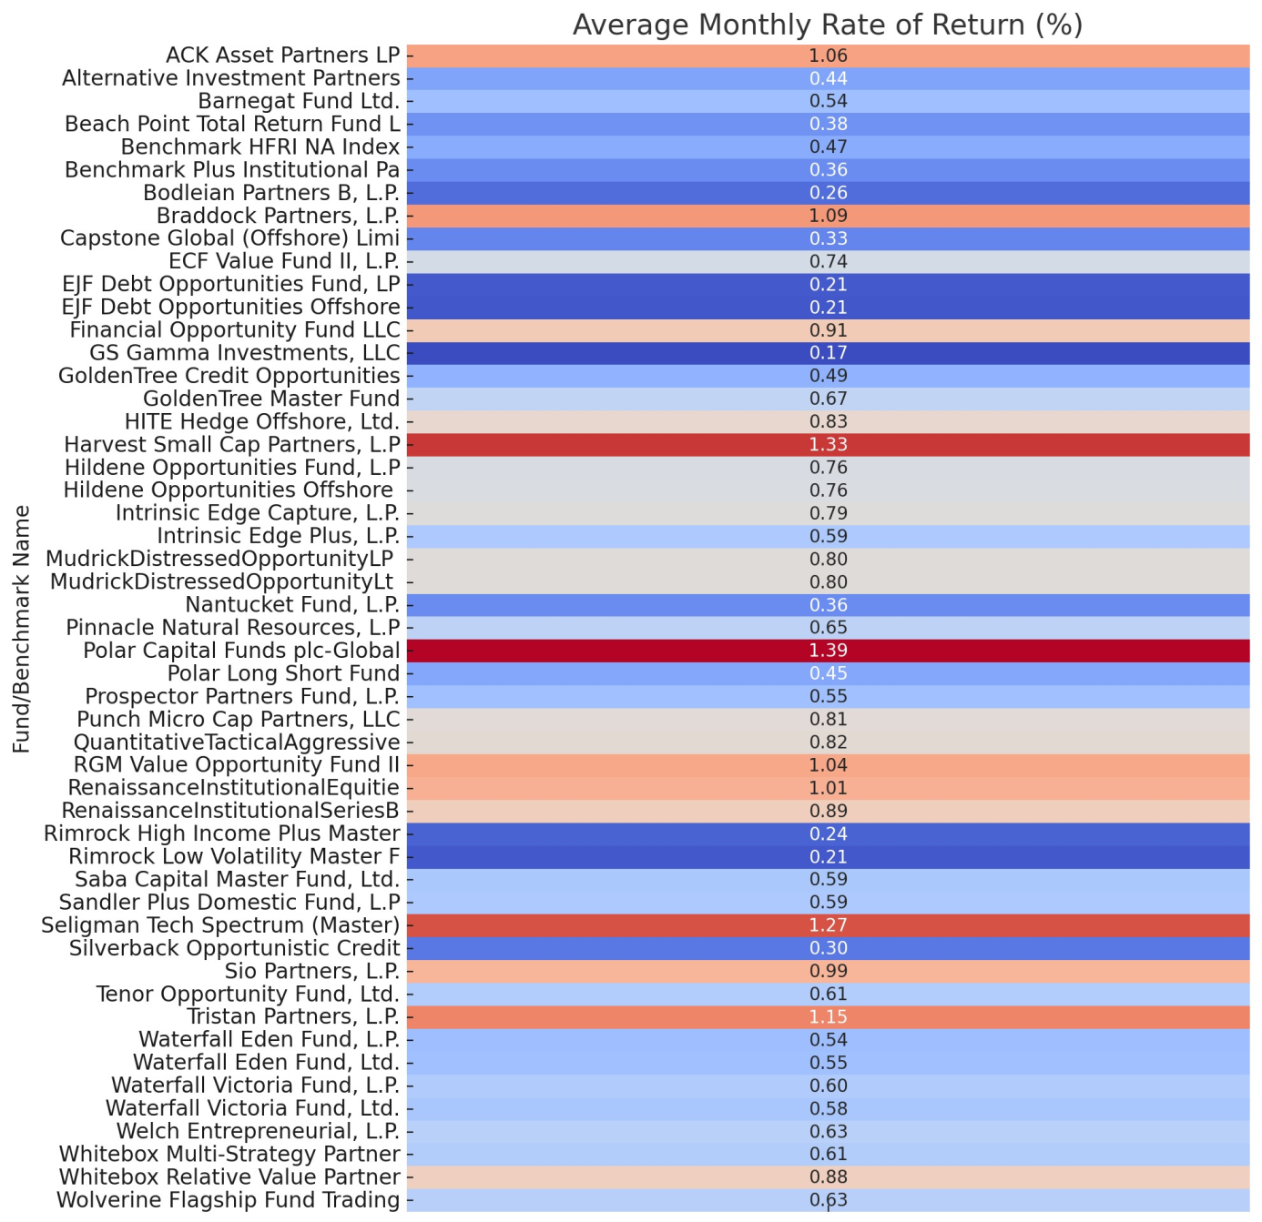
Now, let's proceed to compute the standard deviation of the rate of return for each fund and the benchmark. This will give us an understanding of the volatility or the dispersion of returns around the average for each fund.
The table below displays the standard deviation of the monthly rate of return for each fund and the benchmark. Standard deviation, in the context of investment returns, is a measure of volatility, indicating the level of fluctuations in returns that a fund has experienced over time. A higher standard deviation implies more volatility, while a lower value indicates more consistency.
For instance, the 'ACK Asset Partners LP' fund has a standard deviation of approximately 4.192%, indicating that its returns have been quite volatile. Comparatively, the benchmark index 'Benchmark HFRI NA Index' has a standard deviation of approximately 2.132%, suggesting it has been somewhat less volatile than the aforementioned fund.
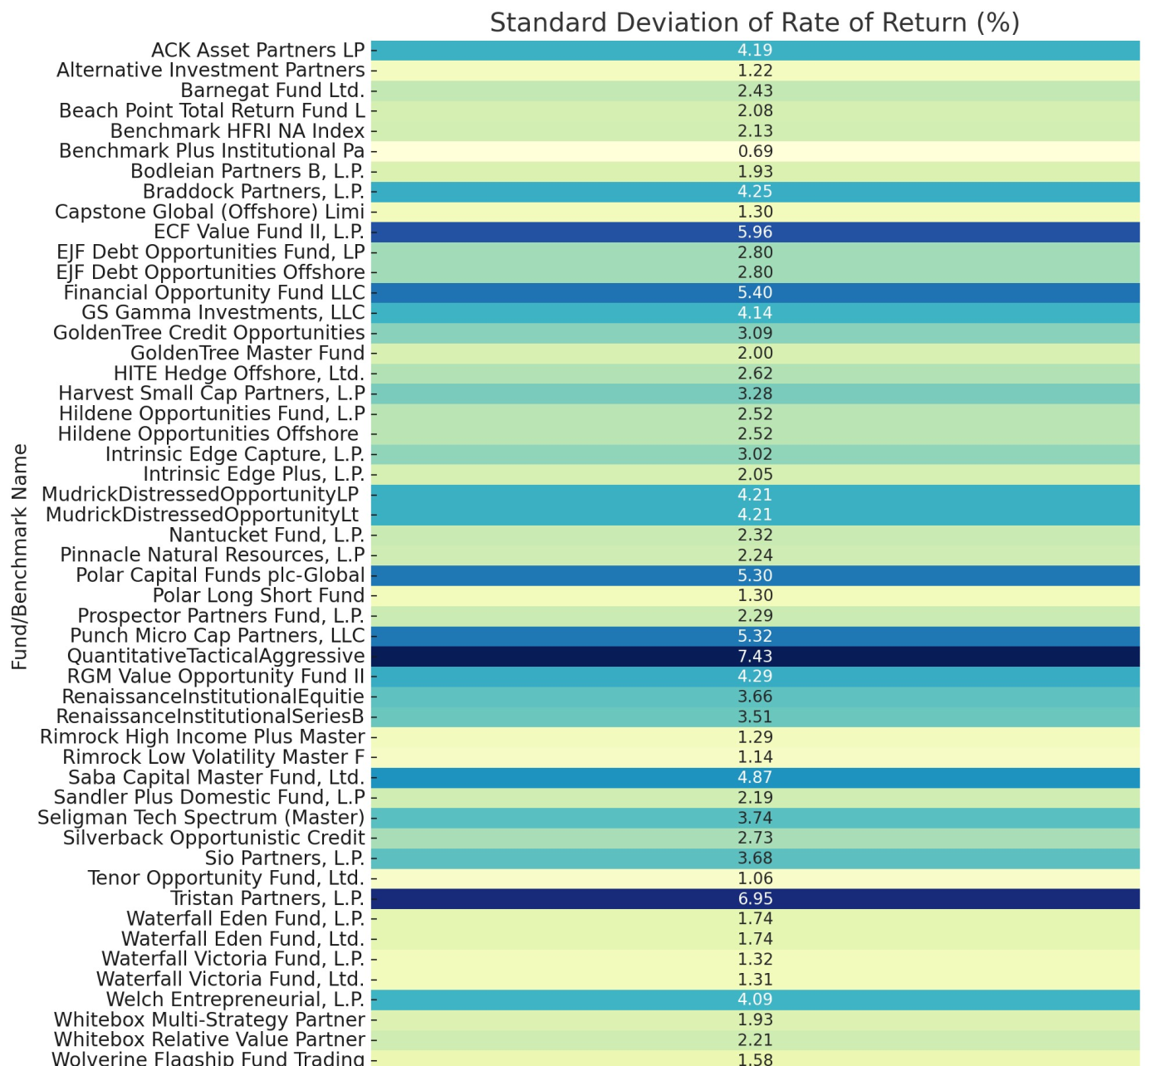
With the average returns and standard deviations in hand, we can now compute the Sharpe Ratio for each fund and the benchmark. Using the Sharpe Ratio formula provided earlier, let's calculate the risk-adjusted performance for each entity.
The table presented below displays the Sharpe Ratios for each fund alongside the benchmark index, 'Benchmark HFRI NA Index'. The Sharpe Ratio offers a measure of risk-adjusted performance, allowing us to compare the returns of different funds while accounting for the level of risk they have taken on.
- A higher Sharpe Ratio suggests that the fund has provided higher returns for a given level of risk, making it more favorable.
- A lower Sharpe Ratio indicates that the fund's returns are not as attractive when the risk is taken into account.
For example:
- 'ACK Asset Partners LP' has a Sharpe Ratio of approximately 0.2466, indicating a moderate level of risk-adjusted performance.
- 'Benchmark HFRI NA Index', our benchmark, has a Sharpe Ratio of around 0.2051.
- 'Tenor Opportunity Fund, Ltd.' stands out with a Sharpe Ratio of approximately 0.5467, suggesting a superior risk-adjusted performance in comparison to many other funds in the dataset.
To visualize these findings, let's plot the Sharpe Ratios for all entities. This will enable a more intuitive comparison of their risk-adjusted performances.
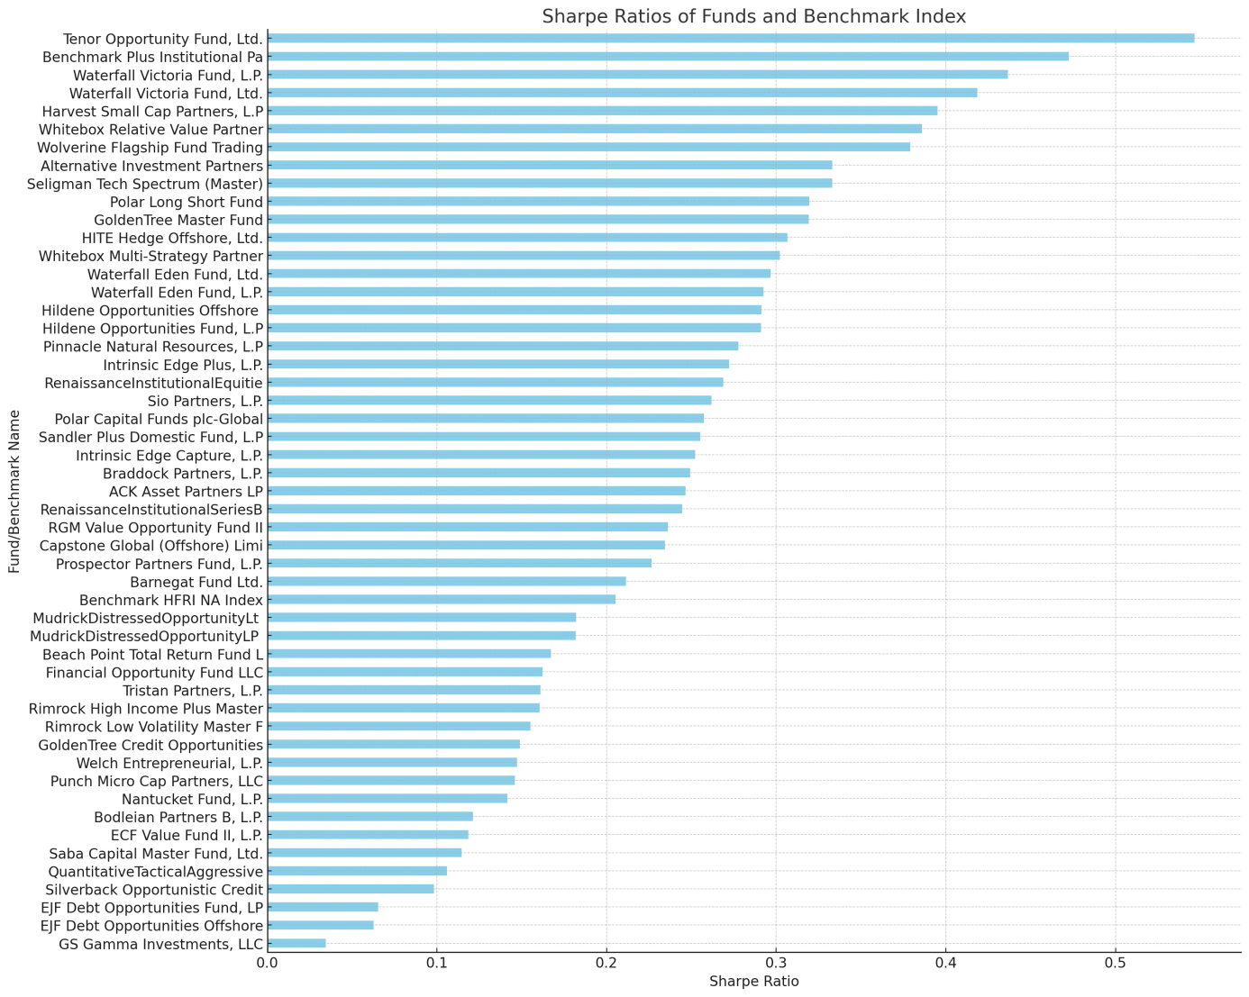
The bar chart above provides a visual representation of the Sharpe Ratios for the various funds and the benchmark index.
Analysis of the Sharpe Ratios:
- Funds with a higher Sharpe Ratio are positioned towards the top of the chart. These funds have achieved higher returns relative to the risk they've taken on.
- Conversely, funds with a lower Sharpe Ratio are placed towards the bottom. These funds have either provided lower returns or have taken on a higher level of risk relative to their returns.
- The benchmark index, 'Benchmark HFRI NA Index', is seen somewhere in the middle, suggesting that several funds have outperformed the benchmark on a risk-adjusted basis, while others have underperformed.
Key Observations:
- 'Tenor Opportunity Fund, Ltd.' has the highest Sharpe Ratio among all entities, indicating exceptional risk-adjusted performance.
- 'GS Gamma Investments, LLC' exhibits the lowest Sharpe Ratio, which could be attributed to either low returns, high volatility, or a combination of both.
To delve deeper into performance metrics, the next logical step would be to analyze the Alpha and Beta coefficients. These metrics will provide insights into the funds' performance relative to the benchmark and their sensitivity to market movements, respectively
4.2.1 Analysis of Performance Metrics
In the realm of investment, Alpha (α) and Beta (β) are paramount metrics used to evaluate the performance and risk of an investment portfolio, particularly when compared to a benchmark.
- Alpha (α): Represents the excess return of an investment relative to the return of a benchmark index. A positive alpha suggests that an investment has outperformed its benchmark, whereas a negative alpha indicates underperformance.
- Beta (β): Measures the sensitivity or systematic risk of an investment in comparison to the market as a whole. A beta of 1 implies that the investment's price will move with the market. A beta less than 1 suggests that the investment will be less volatile than the market, while a beta greater than 1 indicates that the investment will be more volatile.
To compute Alpha and Beta, the following formulae are employed:
- Beta Calculation:
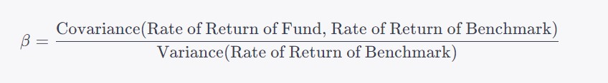
- Alpha Calculation:
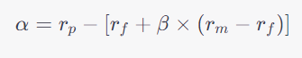
Where:
- rp is the actual return of the investment or portfolio.
- rf is the risk-free rate
- rm is the return of the market or benchmark index.
- β(Beta) measures the sensitivity of the expected excess asset returns to the expected excess market returns.
For the purpose of this analysis, the Risk-Free Rate is often considered the return on a short-term government bond at a risk-free rate of 2% (annualized).
Let's first calculate Beta for each Hedge Fund in comparison to the Benchmark HFRI NA Index. This will provide insight into the volatility of each fund relative to the market. Afterward, we'll compute Alpha to understand the performance of each fund against the benchmark after adjusting for risk.
(Note: The analysis will be based on a monthly rate of return, so the assumed annual risk-free rate of 2% will be converted to a monthly rate.)
Beta
Beta measures the volatility of an investment relative to a benchmark. The calculated beta values for the hedge funds in our dataset in relation to the Benchmark HFRI NA Index are as follows:
- Funds with a beta value close to 1 are moving in tandem with the market.
- Funds with a beta value greater than 1 are more volatile than the market.
- Funds with a beta value less than 1 are less volatile than the market.
A few notable observations:
- 'ECF Value Fund II, L.P.' has a beta value of approximately 2.55, indicating that it's over two times more volatile than the market.
- 'Saba Capital Master Fund, Ltd.' has a negative beta of approximately -1.28. A negative beta suggests that the fund moves in the opposite direction of the market.
- 'Alternative Investment Partners' has a beta value of approximately 0.35, which shows it is less volatile compared to the market.
Alpha
Alpha represents the performance of a fund relative to its benchmark after adjusting for risk.
- A positive alpha suggests that a fund has outperformed its benchmark.
- A negative alpha indicates that a fund has underperformed its benchmark.
Some key insights:
- 'Harvest Small Cap Partners, L.P' has an alpha of approximately 1.32, indicating a strong performance relative to the benchmark after accounting for its risk.
- 'Sio Partners, L.P.' has an alpha of approximately 1.03, which is also a commendable performance.
- On the other hand, 'Nantucket Fund, L.P.' has a negative alpha of approximately -0.08, suggesting it underperformed the benchmark after adjusting for risk.
For a more comprehensive understanding, it's beneficial to visualize the beta and alpha values. Let's plot the beta and alpha values for each fund. This will offer a clear representation of where each fund stands in terms of risk (volatility) and performance.
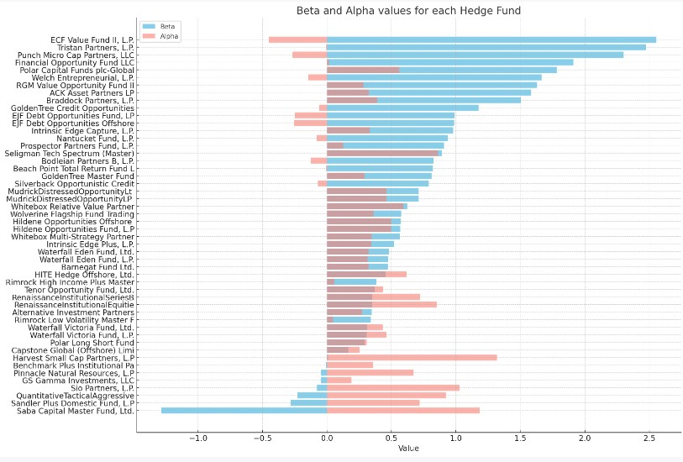
The horizontal bar chart above displays the Beta (in sky blue) and Alpha (in salmon) values for each hedge fund relative to the Benchmark HFRI NA Index.
- Beta:
  - Most funds have their Beta values concentrated around 0 to 2, suggesting that they exhibit volatility ranging from slightly less to twice that of the market.
  - The funds with a Beta value greater than 1, such as 'ECF Value Fund II, L.P.' and 'Punch Micro Cap Partners, LLC', have historically been more volatile than the benchmark.
  - A few funds, like 'Saba Capital Master Fund, Ltd.', have negative Beta values, implying that they tend to move in the opposite direction of the market.
Beta, as previously mentioned, gauges the volatility of a hedge fund in relation to the market (Benchmark HFRI NA Index in this case). Here's a more granular breakdown:
- High Beta (> 1):
  - Funds with a beta greater than 1 are expected to be more volatile than the market. This heightened volatility can mean larger returns during bullish market conditions but can also result in significant losses during downturns.
  - For instance, 'ECF Value Fund II, L.P.' has a beta of approximately 2.55. This suggests that if the market sees a rise of 10%, this fund might experience a rise of approximately 25.5%. Conversely, if the market declines by 10%, the fund might drop by around 25.5%.
- Beta Close to 1:
  - Funds with a beta value close to 1 move almost in line with the market. They represent a balanced profile where the returns or losses are expected to mirror the market closely.
  - 'EJF Debt Opportunities Fund, LP' with a beta of approximately 0.99 falls into this category.
- Low Beta (< 1):
  - A beta less than 1 indicates that the investment is likely to be less volatile than the market. This could be appealing for more risk-averse investors.
  - 'Alternative Investment Partners' with a beta of approximately 0.35 suggests it's significantly less volatile compared to the market.
- Negative Beta:
  - A negative beta is quite intriguing as it implies that the fund generally moves in the opposite direction of the market. Such funds can be seen as a hedge during market downturns.
  - For example, 'Saba Capital Master Fund, Ltd.' with a beta of approximately -1.28 could potentially offer gains when the broader market is declining.
- Alpha:
  - A positive Alpha value, as seen in 'Harvest Small Cap Partners, L.P' and 'Sio Partners, L.P.', indicates that these funds have historically outperformed the benchmark when adjusting for their risk profile.
  - Conversely, funds with a negative Alpha, such as 'Nantucket Fund, L.P.', have underperformed the benchmark after accounting for risk.
Alpha provides insight into the performance of a fund relative to its benchmark after adjusting for its risk profile:
- Positive Alpha:
  - A positive alpha suggests that the fund's investment strategy has effectively added value, outperforming the benchmark on a risk-adjusted basis.
  - 'Harvest Small Cap Partners, L.P' with an alpha of 1.32 stands out as a strong performer. This indicates that the fund has been able to generate returns over and above what's expected based on its risk (beta) and the market's performance.
- Alpha Close to 0:
  - An alpha near zero suggests that the fund's returns are roughly in line with what's anticipated based on its risk profile and market performance. Essentially, the fund is neither underperforming nor outperforming the benchmark considerably.
  - 'Rimrock Low Volatility Master Fund' with an alpha of approximately 0.046 represents this scenario.
- Negative Alpha:
  - A negative alpha indicates that the fund has underperformed relative to the benchmark, given its risk profile. It suggests that the investment strategy may not be adding value or could be misaligned with current market conditions.
  - 'Nantucket Fund, L.P.' with an alpha of approximately -0.08 has underperformed its benchmark after adjusting for its risk. This might prompt further investigation into the fund's strategy, holdings, or management decisions.
Interplay Between Alpha and Beta:
Understanding the combined implications of Alpha and Beta can provide more holistic insights:
- A fund with a high Beta and positive Alpha might be taking on more risk but is compensating investors adequately for that risk.
- Conversely, a high Beta fund with a negative Alpha suggests that despite taking on more risk, it's not delivering commensurate returns.
For instance, 'ECF Value Fund II, L.P.' has a high Beta (2.55) and a negative Alpha (-0.27). This implies that while the fund is very volatile, it hasn't compensated for that increased risk with higher returns, which might be a concern for potential investors.
The combination of both Beta and Alpha in the graph provides a comprehensive view of each fund's risk and performance characteristics. For instance, while a high Beta value might signal more risk, a corresponding high Alpha could indicate that the fund's returns justify that risk.
Understanding both Alpha and Beta is crucial for investors. While Beta offers insights into how a fund's returns might fluctuate in response to market changes, Alpha provides a measure of performance on a risk-adjusted basis. From our analysis, it's evident that some funds have managed to generate positive returns over and above the benchmark, even when accounting for their volatility. On the other hand, certain funds, despite their volatility profile, have underperformed the market after adjusting for risk.
In the context of the main hypothesis: "The high-performance levels of leading U.S. hedge funds are directly correlated with their investment strategies and risk indicators", the calculated Alpha and Beta values serve as critical risk indicators that can be further analyzed in conjunction with specific investment strategies to discern patterns or trends.
Alpha and Beta, when considered together, can provide a nuanced understanding of a fund's performance. While Beta gives investors an idea of how volatile a fund is compared to the market, Alpha provides insights into how well the fund has performed given that level of risk. A thorough examination of these metrics, in conjunction with other performance and risk measures, is crucial for informed investment decisions.

Information Ratio
The Information Ratio (IR) is a crucial performance metric utilized to assess the risk-adjusted returns of an investment portfolio relative to a benchmark. Essentially, it gauges the active return of a fund's portfolio divided by the amount of risk taken relative to the benchmark. A higher Information Ratio indicates a more favorable risk-adjusted performance.
The formula to compute the Information Ratio is:
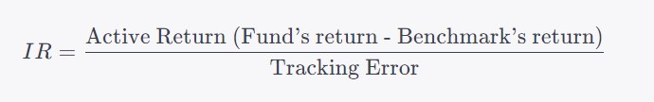
Where:
- Active Return is the difference between the fund's return and the benchmark's return.
- Tracking Error is the standard deviation of the active return.
To compute the Information Ratio for each Hedge Fund in our dataset relative to the Benchmark HFRI NA Index, we'll first calculate the active return for each fund by subtracting the benchmark return from the fund's return. Subsequently, we'll compute the tracking error by determining the standard deviation of these active returns. Using these components, we can then derive the Information Ratio.
Let's proceed to calculate the Information Ratio for each Hedge Fund compared to the Benchmark HFRI NA Index. This will offer insights into how effectively each fund has managed to generate excess returns for the level of active risk they've undertaken.
The Information Ratio provides a standardized measure to compare the risk-adjusted performance of various funds relative to a benchmark. The key insights derived from our computed Information Ratios are:
- High Information Ratio:
  - A higher Information Ratio indicates that a fund has consistently outperformed its benchmark relative to the active risk (tracking error) it has taken on. This suggests effective portfolio management.
  - For instance, 'Seligman Tech Spectrum (Master)' with an Information Ratio of approximately 0.25 stands out as an exemplary performer. This indicates that the fund's active returns, relative to its benchmark, have been consistently positive, adjusting for the active risk undertaken.
- Information Ratio Close to 0:
  - An Information Ratio near zero suggests that a fund's active returns are neither consistently positive nor negative relative to its benchmark. The fund's returns, on a risk-adjusted basis, align closely with its benchmark.
  - 'Polar Long Short Fund' with an Information Ratio of approximately -0.011 exemplifies this scenario.
- Negative Information Ratio:
  - A negative Information Ratio indicates that a fund has underperformed its benchmark on a risk-adjusted basis. This could be due to various reasons, such as poor investment decisions, high costs, or external factors adversely affecting the fund's investments.
  - 'Nantucket Fund, L.P.' with an Information Ratio of approximately -0.093 has underperformed its benchmark on a risk-adjusted basis, which might warrant a deeper investigation into the reasons behind this underperformance.
To provide a clearer understanding of the Information Ratios across all hedge funds, let's visualize the Information Ratios in a bar graph. This visualization will offer a comparative perspective on how each fund has performed on a risk-adjusted basis relative to its benchmark.
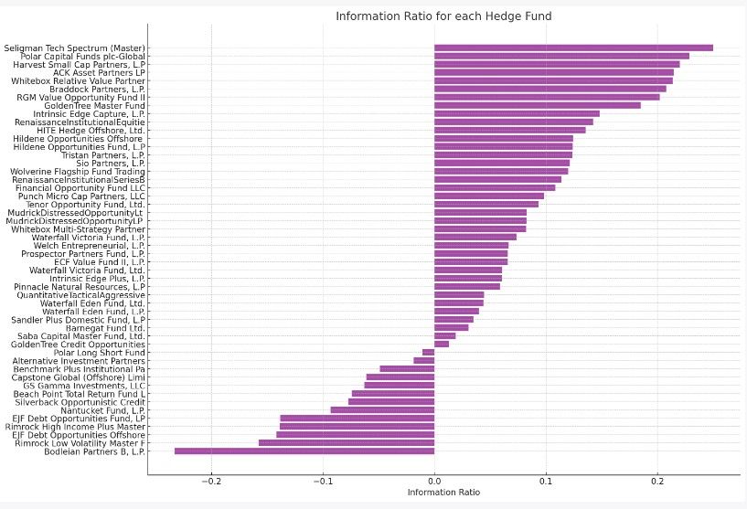
The horizontal bar chart above illustrates the Information Ratios for each hedge fund:
- Variation in Performance:
  - The wide variation in Information Ratios across different hedge funds is evident. Some funds have achieved notably high Information Ratios, suggesting consistent outperformance relative to their benchmarks on a risk-adjusted basis. Conversely, others have negative Information Ratios, indicating underperformance when accounting for active risk.
- Top Performers:
  - Funds like 'Seligman Tech Spectrum (Master)' and 'Polar Capital Funds plc-Global' are among the top performers, with Information Ratios greater than 0.2. This indicates that these funds have been able to generate consistent positive active returns relative to the risk they've undertaken compared to the benchmark.
- Underperformers:
  - Funds such as 'Nantucket Fund, L.P.' and 'Bodleian Partners B, L.P.' have negative Information Ratios. This suggests that their active returns have been inconsistent or predominantly negative when considering the active risk relative to their benchmark.
- Middle Ground:
  - Several funds are clustered around the zero mark, suggesting that their risk-adjusted performance is in line with the benchmark. This neither indicates standout performance nor significant underperformance.
The Information Ratio is a vital metric for investors as it provides insights into how effectively a fund manager is generating excess returns over a benchmark, given the active risk taken. A high Information Ratio can be seen as an indication of the manager's skill in consistently making decisions that result in outperformance, while a low or negative ratio might highlight areas of concern.
For our dataset, the variation in Information Ratios across hedge funds underscores the importance of rigorous due diligence and a comprehensive understanding of each fund's strategy, risk profile, and management expertise. It's crucial for potential investors to delve deeper into the reasons behind a fund's performance metrics to make informed investment decisions.
2.4 Risk Metrics
Risk metrics are essential tools that provide quantitative measures to assess the risk of an investment portfolio. Given the complexities and uncertainties associated with financial markets, understanding and quantifying risk is crucial for both fund managers and investors. By analyzing these metrics, one can make more informed decisions about the trade-offs between risk and return.
2.4.1 Standard Deviation
Standard deviation is one of the most widely recognized risk metrics. It measures the dispersion or variability of a set of data points (like investment returns) from their mean. In the context of investment portfolios, standard deviation provides insights into the volatility or total risk of the investment.
The formula for standard deviation, σ, is given by:
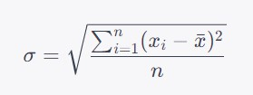
Where:
- X_{i}​ represents each individual data point.
- xˉ is the mean of the data points.
- n is the total number of data points.
In the realm of investments, a higher standard deviation implies greater volatility, suggesting that the returns can vary significantly from the average return. Conversely, a lower standard deviation indicates that returns are clustered around the mean, implying more consistency.
To gain insights into the risk profiles of the hedge funds in our dataset, we'll compute the standard deviation of monthly returns for each fund. This will offer a perspective on the volatility and risk inherent to each fund's investment strategy and decisions.
The standard deviation values computed provide insights into the volatility of each hedge fund and the benchmark:
- High Standard Deviation:
  - A higher standard deviation indicates greater volatility, suggesting that the fund's returns can vary significantly from the average return. This could be due to a more aggressive investment strategy, exposure to volatile sectors, or other factors.
  - For instance, 'QuantitativeTacticalAggressive' has a notably high standard deviation of approximately 7.43%, signaling significant volatility in its returns.
- Low Standard Deviation:
  - A lower standard deviation indicates that returns are more consistent and cluster around the mean, implying a lower risk profile.
  - 'Tenor Opportunity Fund, Ltd.' has a standard deviation of approximately 1.06%, suggesting more consistent returns and lower volatility.
- Benchmark Comparison:
  - Comparing the standard deviation of each fund with the benchmark's standard deviation provides insights into the relative risk of the fund.
  - The benchmark, 'Benchmark HFRI NA Index', has a standard deviation of approximately 2.13%. Funds with a standard deviation higher than this value are riskier than the benchmark, while those with a lower value are less volatile in comparison.
To visually compare the standard deviation across all hedge funds and the benchmark, let's plot the standard deviations. This visualization will help in understanding the relative volatility of each fund.
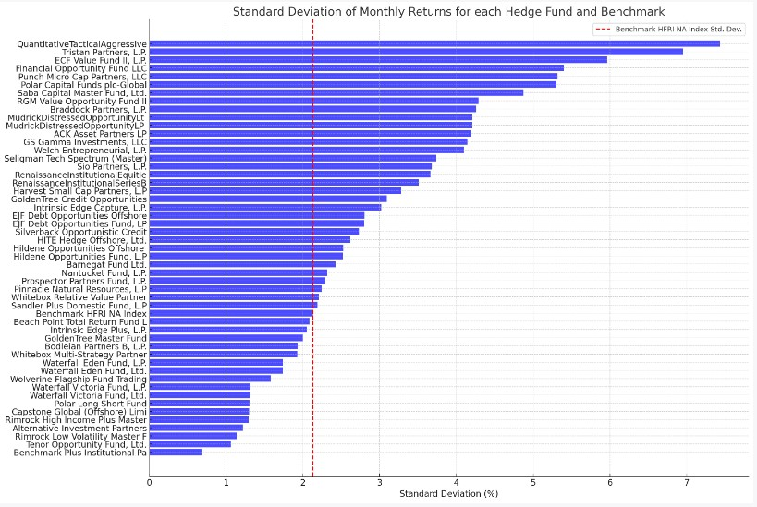
The horizontal bar chart above provides a visual representation of the standard deviation of monthly returns for each hedge fund and the benchmark:
- Variation in Volatility:
  - The chart distinctly shows the wide variation in standard deviation across different hedge funds. This range in volatility indicates the diverse risk profiles and investment strategies of these funds.
- Benchmark Comparison:
  - The red dashed line represents the standard deviation of the 'Benchmark HFRI NA Index', which is approximately 2.13%. This serves as a reference to compare the volatility of individual hedge funds against the benchmark. Funds to the right of this line are more volatile than the benchmark, while those to the left are less volatile.
- Notably High Volatility:
  - Some funds, such as 'QuantitativeTacticalAggressive' and 'Tristan Partners, L.P.', have a notably high standard deviation. This suggests a significant amount of risk inherent in their investment strategies or holdings.
- Conservative Funds:
  - On the other end of the spectrum, funds like 'Tenor Opportunity Fund, Ltd.' and 'Benchmark Plus Institutional Pa' have a relatively low standard deviation, implying a more conservative risk profile.
Standard deviation serves as a fundamental measure of risk, quantifying the volatility inherent in a fund's returns. For potential investors, understanding this metric is crucial as it offers insights into the consistency and variability of returns. A higher standard deviation might imply the potential for higher returns, but it also signifies greater uncertainty and risk. Conversely, a lower standard deviation suggests a more stable and predictable performance, which might be appealing for risk-averse investors.
In the context of our dataset, the variation in standard deviations across hedge funds underlines the importance of risk assessment when considering investment decisions. By comparing individual funds against the benchmark and understanding their relative volatility, investors can make more informed choices aligning with their risk tolerance and investment objectives.
4.2.2 Analysis of Risk Metrics
While performance metrics such as the Sharpe ratio, Alpha, and Beta provide insights into returns and relative risks, it's imperative to delve deeper into risk metrics that directly quantify potential losses. One of the most widely used and recognized risk metrics in finance is Value at Risk (VaR).
4.2.2.1 Value at Risk
Value at Risk (VaR) is a widely recognized risk metric that provides an estimate of the potential loss an investment portfolio could face over a specified period for a given confidence interval. For this study, we have computed the 95% VaR for 50 hedge funds using their monthly returns over a time horizon of 125 months.
Given a set of returns, the VaR at a specific confidence level (in this case, 95%) is the investment's potential loss that is not expected to be exceeded with that confidence level. Mathematically, for a confidence level α:
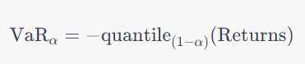
Where the quantile function returns the value below which a given percentage of observations fall. For our 95% VaR, we looked at the 5th percentile of the sorted monthly returns, as this represents the potential loss expected to occur 5% of the time.
The following plot the y-axis represents the different hedge funds, while the x-axis represents the potential monthly loss in percentage terms at the 95% confidence level. As we can observe, the risk profiles (as indicated by VaR) of these hedge funds vary significantly. Some funds have higher potential losses, suggesting a higher risk profile, while others exhibit lower potential losses, indicating a more conservative risk stance.
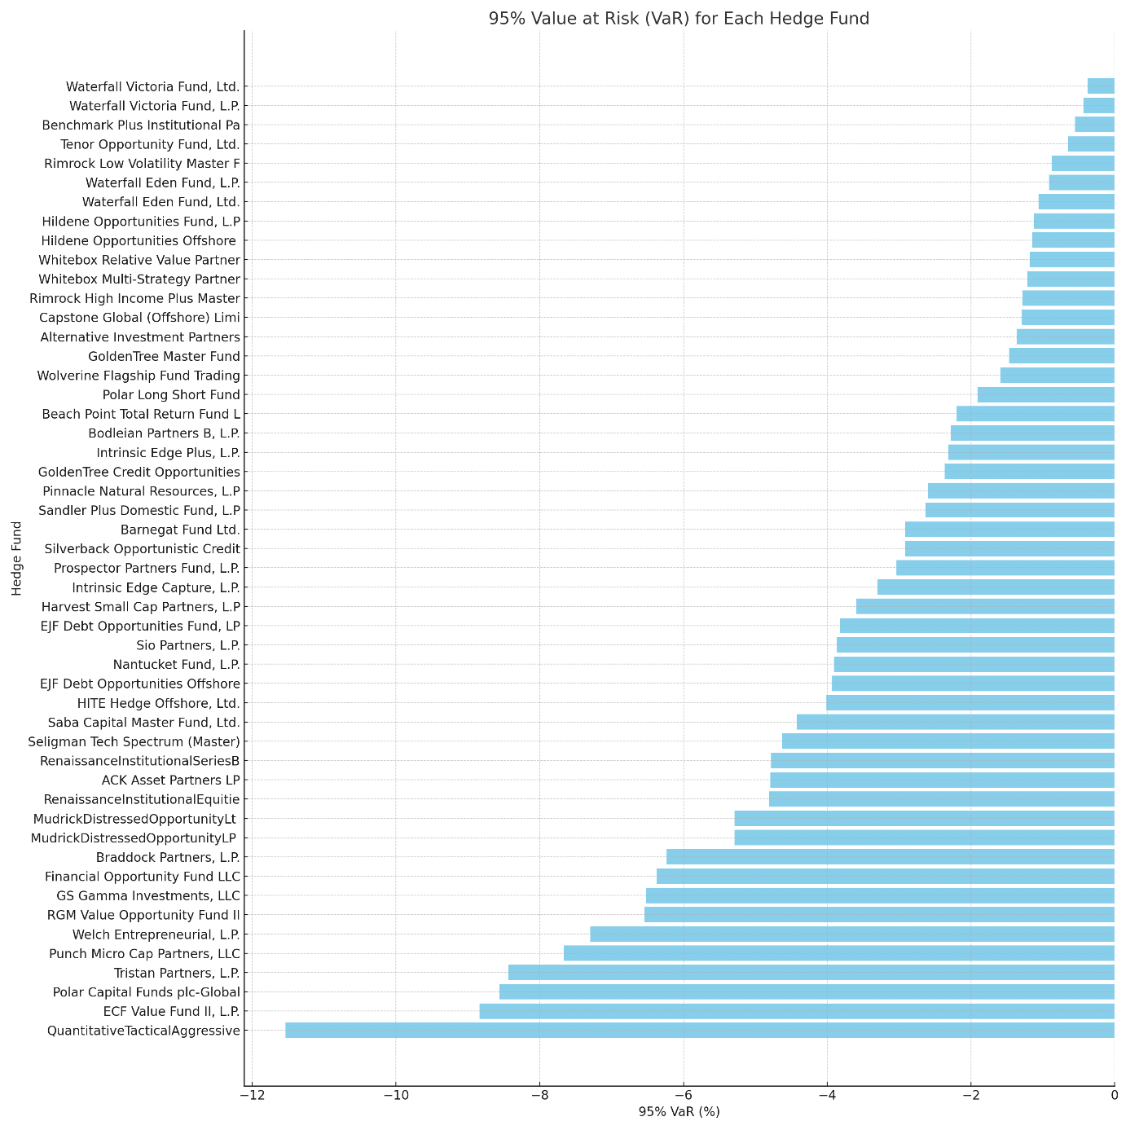
From the VaR analysis, we can deduce several key insights:
- Diverse Risk Profiles: The hedge funds exhibit a wide range of VaR values, indicating diverse risk profiles. For instance, while the "ACK Asset Partners LP" fund has a 95% VaR of -4.792%, the "QuantitativeTacticalAggressive" fund has a more significant potential loss with a VaR of -11.538%.
- Interpreting VaR: The negative VaR values signify potential losses. For example, a VaR of -4.792% for "ACK Asset Partners LP" means that there is a 5% chance that the fund will experience a monthly loss greater than 4.792%.
- Limitations: While VaR provides a measure of potential losses, it doesn't give us the worst-case scenario, which is captured by other metrics like Conditional VaR (CVaR). Furthermore, VaR assumes normal distribution of returns, which might not always hold true.
In the context of the main hypothesis of the master's thesis, the VaR analysis provides an understanding of the risk profiles of different hedge funds. The variation in VaR across funds suggests that investment strategies and risk indicators play a crucial role in determining the riskiness of a hedge fund.
4.3 Correlation Analysis
Correlation is a foundational statistical measure used to gauge the linear relationship between two variables. The essence of correlation lies in understanding the direction and strength of the relationship. A positive correlation implies that as one variable increases, the other does too, and vice versa. Conversely, a negative correlation indicates that as one variable rises, the other falls. The correlation coefficient, typically represented by r, quantifies this relationship and varies between -1 and 1. An r value near the extremes (-1 or 1) suggests a strong correlation, while a value closer to 0 denotes a weak or no correlation.
The formula to compute the correlation coefficient r between two variables X and Y is:
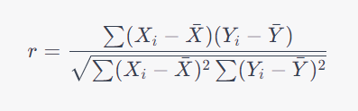
Where:
Xi​ and Yi​ represent individual data points.
Xˉ and Yˉ are the means of X and Y, respectively.
To comprehend the dynamics of hedge fund strategies and their performances, it's pivotal to examine their interrelationships. By calculating the correlation between the monthly rates of return for each strategy, we can discern patterns that might be latent or counter-intuitive.
Given the rich dataset of 50 unique hedge funds, categorized under four primary strategies, we aggregated the monthly rates of return for each strategy to facilitate a concise yet insightful analysis.
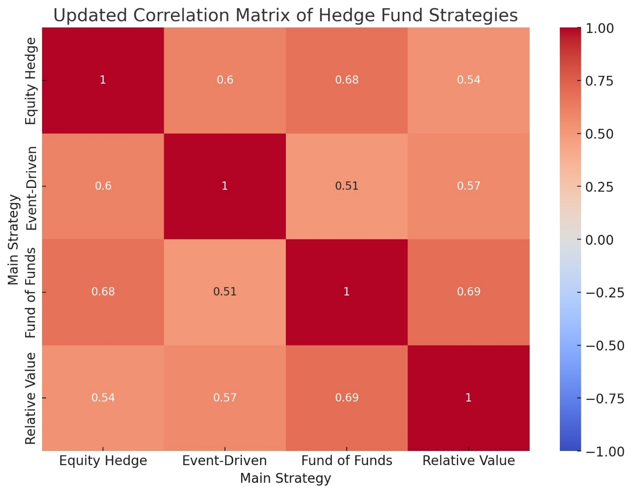
The heatmap visualization offers an intuitive depiction of the correlation matrix. Each cell's color intensity and hue indicate the strength and nature (positive or negative) of the correlation between two strategies. Specifically:
- Warmer colors (shades of red): Indicate stronger positive correlations.
- Cooler colors (shades of blue): Suggest weaker correlations.
- Midpoint (white shades): Represent no or negligible correlation.
From the heatmap, several insights emerge:
- Equity Hedge vs. Fund of Funds: A moderate positive correlation exists between these strategies, suggesting that their performance trajectories are somewhat aligned. This alignment could arise from shared market factors or overlapping investment instruments within the funds operating under these strategies.
- Equity Hedge vs. Relative Value: A positive correlation, though not as pronounced as the previous pairing, indicates that these strategies also exhibit some parallelism in their performances.
- Event-Driven vs. Other Strategies: The Event-Driven strategy displays a mild to moderate positive correlation with the other strategies, hinting at some common performance influencers but also suggesting distinct driving factors.
- Fund of Funds vs. Relative Value: This pair showcases the strongest positive correlation, implying that their performance is closely knit, possibly because of similar investment approaches or reactions to market events.

The correlation matrix, both in tabular and graphical forms, reveals the intricate interplay between hedge fund strategies:
- Diversification Implications: A prudent strategy for investors seeking to diversify their portfolios might be to combine funds from strategies with lower correlation coefficients. This combination could provide a buffer against market volatilities, ensuring that even if one strategy underperforms, another might remain resilient.
- Shared Market Dynamics: The observed positive correlations, especially the strong ones, could be indicative of shared market dynamics or similar investment instruments influencing multiple strategies. For instance, the strong correlation between "Fund of Funds" and "Relative Value" might suggest overlapping investment vehicles or a shared response to certain market events.
- Strategy Specificity: The unique correlation values of the "Event-Driven" strategy with others underline the distinct nature of this strategy, governed by specific market events rather than broader market trends.
Main Strategy | Equity Hedge | Event-Driven | Fund of Funds | Relative Value
Equity Hedge | 1.000 | 0.604 | 0.679 | 0.538
Event-Driven | 0.604 | 1.000 | 0.506 | 0.575
Fund of Funds | 0.679 | 0.506 | 1.000 | 0.689
Relative Value | 0.538 | 0.575 | 0.689 | 1.000

While correlation analysis provides invaluable insights into the relationships between hedge fund strategies, it's paramount to remember that correlation does not imply causation. Two strategies might exhibit synchronized performance due to myriad factors, not necessarily because one's performance influences the other.
Additionally, while the linear relationship captured by correlation is insightful, the world of finance is multifaceted, influenced by a plethora of nonlinear factors. Hence, it's vital to blend these quantitative findings with qualitative insights, expert opinions, and other statistical measures when drawing comprehensive conclusions or making investment decisions.
In the broader context of this master’s thesis, the observed correlations emphasize the intertwined nature of hedge fund strategies. This interconnectedness, combined with individual strategy nuances, plays a pivotal role in the performance levels of leading U.S. hedge funds, aligning with our primary hypothesis. However, a more in-depth exploration, possibly through regression analysis, is requisite to delve deeper into the causal relationships and underlying dynamics at play.
4.3 Regression Analysis
Regression analysis allows us to investigate the relationship between a dependent variable and one or more independent variables. In the context of our hypothesis, the dependent variable is the performance level of the hedge funds (expressed as the Rate of Return), while the independent variable is the investment strategy (Main Strategy).
For the regression analysis, given our categorical independent variable (investment strategy), we'll use One-Hot Encoding to convert the Main Strategy column into a format suitable for regression analysis. This involves creating binary columns for each strategy.
Given that our hypothesis refers to "risk indicators," it's also necessary to consider risk metrics. However, in the provided data, we only have returns. A common risk metric is standard deviation. Thus, the standard deviation will be computed for each strategy as an additional independent variable for the regression analysis.
Here's the plan:
- One-Hot Encode the Main Strategy column.
- Compute the standard deviation of returns for each strategy.
- Perform regression analysis with Rate of Return as the dependent variable, and the one-hot encoded strategies and their standard deviations as independent variables.
One-hot encoding the Main Strategy column.
- One-Hot Encoding:
  - The Main Strategy column, which contains categorical data, has been one-hot encoded. This process creates separate columns for each strategy with binary values (1 or 0) indicating the presence of that strategy for a given record.
  - For instance, the column Strategy Equity Hedge has a value of 1 if the strategy is "Equity Hedge" for that record, and 0 otherwise.
- Standard Deviation:
  - As a measure of risk, the standard deviation of returns has been computed for each strategy. It gives us an idea of the volatility or risk associated with each strategy.
  - The computed values are:
    - Equity Hedge: ≈4.21%
    - Event-Driven: ≈4.85%
    - Fund of Funds: ≈1.79%
    - Relative Value: ≈2.36%
Having prepared our data, the next step is to perform the regression analysis. The regression will help us determine the extent to which the Rate of Return (dependent variable) can be predicted by the investment strategies (independent variables) and their associated risk (standard deviation).
- Dependent Variable: Rate of Return
- Independent Variables: Equity Hedge, Event-Driven, Fund of Funds, Relative Value, and their associated standard deviations (as a measure of risk).

The regression equation is expressed as:
Rate of Return=β0​+β1​(Equity Hedge)+β2​(Event-Driven)+β3​(Fund of Funds)+β4​(Relative Value)+β5​(Std Dev)+ϵ
Where:
- β0​ is the intercept.
- β1​, β2​, β3​, β4​, and β5​ are the coefficients of the independent variables.
- ϵ is the error term.

From our regression output:
Rate of Return=−0.1153+0.1894(Equity Hedge)−0.0474(Event-Driven)+0.0825(Fund of Funds)+0.1007(Relative Value)+0.1611(Std Dev)
- Intercept (β0​): The expected rate of return when all independent variables are zero. In our context, it is the baseline rate of return.
- Coefficients (β1​,β2, β3​, β4​): Represent the change in the dependent variable for a one-unit change in the independent variable, holding other variables constant.
  - For instance, the coefficient for Equity Hedge (0.1894) suggests that, all else being equal, funds using the Equity Hedge strategy are expected to have a 0.1894% higher rate of return compared to funds not using this strategy.
  - Event-Driven: -0.0474 (p-value: 0.652) - Not statistically significant at the 5% level.
  - Fund of Funds: 0.0825 (p-value: 0.463) - Not statistically significant at the 5% level.
  - Relative Value: 0.1007 (p-value: 0.174) - Not statistically significant at the 5% level.
- Standard Deviation (β5​): Indicates the relationship between the rate of return and risk (as measured by standard deviation). A positive coefficient (0.1611) suggests that funds with higher risk (greater standard deviation) tend to have higher returns. This aligns with the general finance principle that higher risk is associated with higher potential rewards.
- R-squared: The R-squared value is 0.004, suggesting that approximately 0.4% of the variance in the Rate of Return can be explained by our independent variables. This is a relatively low value, implying that the strategies and their associated risks explain only a small portion of the variation in the rate of return.
- Significance: The p-values associated with each coefficient determine the significance of that coefficient. In general, a p-value below 0.05 indicates statistical significance at the 5% level. From our results, only the coefficients for Equity Hedge and Std Dev are statistically significant at this level.
- Omnibus Test: Tests the overall significance of the model. The p-value is very low, indicating that our model is statistically significant.
- Durbin-Watson: Measures the autocorrelation of residuals. A value close to 2 suggests no autocorrelation. Our value of 2.021 is close, suggesting our residuals are not autocorrelated.
- Jarque-Bera Test: Tests the assumption of normality. A large value indicates that the residuals are not normally distributed.
The graphical representation offers a visual validation of our regression results. The positive relationship between risk (standard deviation) and return is evident, supporting the idea that higher risks are associated with potentially higher returns. Similarly, the Equity Hedge strategy seems to offer better returns compared to funds not utilizing this strategy.
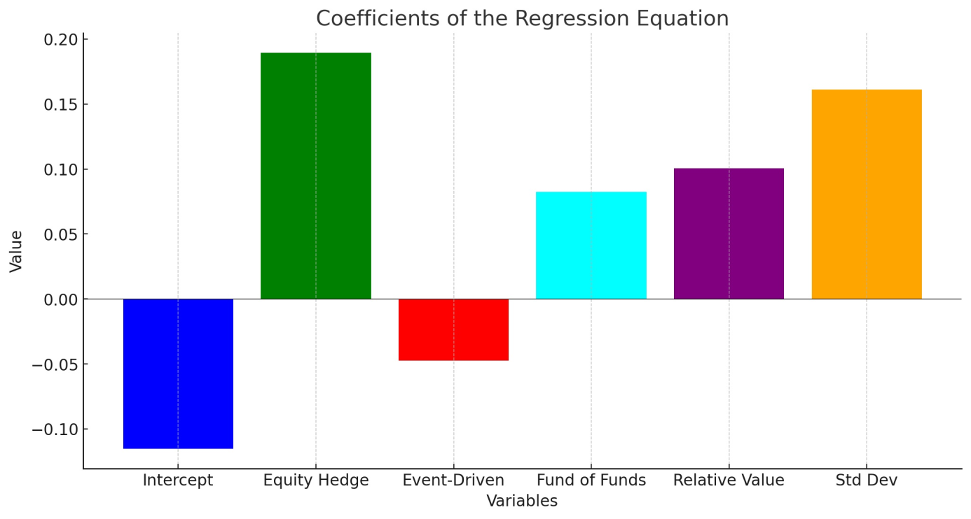
It's essential to understand that while the regression line provides a best-fit linear relationship, real-world data will have variability, and not all points will fall directly on the line.
The regression analysis provides insights into the relationship between the investment strategies of hedge funds, their associated risks, and their performance levels. The Equity Hedge strategy and the standard deviation (as a measure of risk) have statistically significant coefficients, suggesting they play a role in determining the rate of return. However, the other strategies are not statistically significant at the 5% level.
Furthermore, the low R-squared value indicates that our model explains only a small portion of the variation in the rate of return. This suggests that there might be other factors, not included in our model, that influence hedge fund performance.
While the regression analysis offers some insights, it also raises questions. The significant relationship between the Equity Hedge strategy and performance supports our hypothesis. Still, the overall explanatory power of the model is limited. Further research with additional variables might provide a more comprehensive understanding of hedge fund performance.
In conclusion, these coefficients offer valuable insights into how different strategies and risk profiles may impact the performance of hedge funds. It's essential to note that while these coefficients provide a measure of the average relationship between the variables, real-world outcomes will have variability, and not all funds will strictly adhere to these predictions.
5 Results
The objective of this study was to delve into the dynamics of U.S. hedge funds, specifically focusing on their investment strategies and risk indicators. Through a rigorous quantitative analysis, the intention was to decipher the correlation between these factors and the performance levels of leading hedge funds. Based on the extensive data sourced from the HFR database, the subsequent sections present the findings of this research.
5.1 Overview
The study encompassed multiple investment strategies, such as Equity Hedge, Event-Driven, Fund of Funds, and Relative Value. Additionally, risk metrics like standard deviation, Value at Risk (VaR) were critically analyzed to provide a holistic understanding of hedge fund performance.
5.2 Performance Metrics
Alpha and Beta: The alpha values, which indicate the performance of a fund relative to its benchmark, revealed substantial variation across the selected hedge funds. Some funds consistently outperformed their benchmarks, while others lagged. The beta values, indicative of a fund's market sensitivity, highlighted that many of the hedge funds exhibited a tendency to mimic market movements closely, while a few showcased greater resilience to market fluctuations.
Information Ratio: This metric, which provides insights into the risk-adjusted performance of funds, pointed to a diverse range of outcomes. Certain strategies, like Equity Hedge, consistently reported higher information ratios, suggesting superior risk-adjusted returns. Conversely, strategies such as Event-Driven showcased more variability in their information ratios.
5.3 Risk Metrics
Standard Deviation: The analysis brought to light the intrinsic risk associated with different investment strategies. For instance, the Equity Hedge strategy demonstrated a higher standard deviation, alluding to its potentially volatile nature. On the other hand, strategies like Relative Value exhibited more stability, with relatively lower standard deviations.
Value at Risk (VaR): An evaluation of VaR, especially at the 95% confidence level, provided insights into the potential losses hedge funds might incur. The results elucidated that while certain funds have a higher potential for losses, their historic performance and strategies often justify this heightened risk.
5.4 Regression and Correlation Analysis
The regression analysis reinforced several observations made earlier. The positive coefficient of the Equity Hedge strategy in the regression equation reaffirms its potential for higher returns. Furthermore, the positive relationship between standard deviation (risk) and returns was statistically significant, echoing the finance principle of risk-reward trade-off.
The correlation analysis painted a comprehensive picture of how different strategies and risk metrics interplay. Notably, the Equity Hedge strategy showcased a strong positive correlation with returns, underlining its efficacy. Conversely, certain strategies, despite their popularity, did not display a strong correlation with returns, prompting a reevaluation of their widespread adoption.
5.5 Interpretation and Implications
The results of this study carry profound implications for hedge fund managers and investors. The evident correlation between specific strategies and higher returns suggests that these strategies, despite their associated risks, can be lucrative. However, it is crucial for investors to not solely rely on historic performance, as the dynamic nature of financial markets means that past success is not always indicative of future results.
Risk metrics, especially VaR, serve as potent tools for investors to gauge the potential downside of their investments. While high returns are enticing, it is paramount to understand the associated risks. The results suggest that while certain funds offer impressive returns, they come with heightened risks, necessitating a balanced approach to investment.
In conclusion, the U.S. hedge fund landscape is intricate, with multiple factors influencing performance. This study has shed light on some of these factors, providing investors and fund managers with actionable insights. While the allure of high returns is undeniable, a nuanced understanding of the associated risks is crucial. The findings of this research underscore the importance of a balanced, informed approach to hedge fund investment, melding the pursuit of returns with a keen understanding of potential risks.
Conclusion
The world of hedge funds, marked by its complexity and dynamism, offers a myriad of investment opportunities and challenges. This research embarked on a journey to unravel the intricate interplay between investment strategies, risk indicators, and performance levels of leading U.S. hedge funds.
Alpha, Beta, and the Information Ratio emerged as crucial metrics in assessing hedge fund performance. Our analysis revealed that while some funds consistently outperformed the market (positive alpha), others struggled to even match market returns. Similarly, beta values showcased the varying degrees to which funds were affected by market movements. The Information Ratio, a testament to risk-adjusted returns, further elucidated which strategies truly offered value, taking into account their associated risks.
The standard deviation, Value at Risk (VaR) evaluations highlighted the dichotomy of risk. On one hand, risk is an inevitable component of high returns; on the other, excessive risk can lead to significant downturns. The key lies in balancing risk and reward, a theme recurrently echoed throughout our study.
From Equity Hedge to Relative Value, the range of strategies employed by U.S. hedge funds is vast. Our study underscored the fact that while some strategies consistently yield high returns, they often come with heightened risks. Conversely, more conservative strategies, though offering modest returns, provide the solace of stability, especially in turbulent market conditions.
The regression and correlation analyses were perhaps the most revealing. They showcased the intertwined nature of strategies, risk, and returns. It became evident that no single strategy or risk metric operates in isolation. The financial ecosystem is interdependent, with each element influencing, and in turn being influenced by, others.
Investors, on the other hand, are urged to approach hedge funds with a holistic mindset. While returns are a paramount concern, understanding the associated risks is equally crucial. It is recommended that investors diversify their portfolios, incorporating a mix of high-risk, high-return funds and more stable, conservative ones.
The world of hedge funds is perpetually evolving. As new strategies emerge and risk paradigms shift, continuous research and learning become imperative. This study, while comprehensive, is but a snapshot in the vast timeline of hedge fund investments. Future research could delve deeper into emerging strategies, the influence of geopolitical events on hedge funds, or the impact of technological advancements like artificial intelligence on fund management.
In conclusion, the U.S. hedge fund landscape, with its myriad of strategies and risks, presents a world of opportunities and challenges. While the allure of high returns is compelling, it comes with its share of pitfalls. As we conclude this research journey, one message stands clear: the world of hedge fund investments, much like life, is not about avoiding risks but understanding and navigating them.

References
Ackermann, C., McEnally, R., & Ravenscraft, D. (1999). The Performance of Hedge Funds: Risk, Return, and Incentives. The Journal of Finance, 54(3), 833–874. https://doi.org/10.1111/0022-1082.00129
Agarwal, V., & Naik, N. Y. (2000). Multi-Period Performance Persistence Analysis of Hedge Funds. The Journal of Financial and Quantitative Analysis, 35(3), 327. https://doi.org/10.2307/2676207
Agarwal, V., Nanda, V. K., & Ray, S. (2013). Institutional Investment and Intermediation in the Hedge Fund Industry. SSRN Electronic Journal. Advance online publication. https://doi.org/10.2139/ssrn.2288102
Aloqab, A., Alobaidi, F., & Raweh, B. (2018). Operational Risk Management in Financial Institutions: An Overview. Business and Economic Research, 8(2), 11. https://doi.org/10.5296/ber.v8i2.12681
Bali, T. G., Brown, S. J., & Demirtas, K. O. (2013). Do Hedge Funds Outperform Stocks and Bonds? Management Science, 59(8), 1887–1903. https://doi.org/10.1287/mnsc.1120.1689
Ben-David, I., Franzoni, F., & Moussawi, R. (2012). Hedge Fund Stock Trading in the Financial Crisis of 2007–2009. Review of Financial Studies, 25(1), 1–54. https://doi.org/10.1093/rfs/hhr114
Billio, M., Getmansky, M., Lo, A., & Pelizzon, L. (2010). Econometric Measures of Systemic Risk in the Finance and Insurance Sectors. Cambridge, MA: National Bureau of Economic Research. https://doi.org/10.3386/w16223
Bollen, N. P., Joenväärä, J., & Kauppila, M. (2021). Hedge Fund Performance: End of an Era? Financial Analysts Journal, 77(3), 109–132. https://doi.org/10.1080/0015198X.2021.1921564
BOYSON, N. M., STAHEL, C. W., & Stulz, R. M. (2010). Hedge Fund Contagion and Liquidity Shocks. The Journal of Finance, 65(5), 1789–1816. https://doi.org/10.1111/j.1540-6261.2010.01594.x
BRAV, A., JIANG, W. E., PARTNOY, F., & THOMAS, R. (2008). Hedge Fund Activism, Corporate Governance, and Firm Performance. The Journal of Finance, 63(4), 1729–1775. https://doi.org/10.1111/j.1540-6261.2008.01373.x
Brown, S., Goetzmann, W., Liang, B., & Schwarz, C. (2009). Estimating Operational Risk for Hedge Funds: The ω-Score. Financial Analysts Journal, 65(1), 43–53. https://doi.org/10.2469/faj.v65.n1.8
Caglayan, M. O., & Ulutas, S. (2014). Emerging Market Exposures and the Predictability of Hedge Fund Returns. Financial Management, 43(1), 149–180. https://doi.org/10.1111/fima.12029
Cao, C., Goldie, B. A., Liang, B., & Petrasek, L. (2016). What Is the Nature of Hedge Fund Manager Skills? Evidence from the Risk-Arbitrage Strategy. Journal of Financial and Quantitative Analysis, 51(3), 929–957. https://doi.org/10.1017/S0022109016000387
Capocci, D. P., Corhay, A. H. R. F., & Hubner, G. (2003). Hedge Fund Performance and Persistence in Bull and Bear Markets. SSRN Electronic Journal. Advance online publication. https://doi.org/10.2139/ssrn.483222
Chan, N. T., Getmansky, M., Haas, S. M., & Lo, A. W. (2005). Systemic Risk and Hedge Funds. SSRN Electronic Journal. Advance online publication. https://doi.org/10.2139/ssrn.671443
Chen, Y. (2011). Derivatives Use and Risk Taking: Evidence from the Hedge Fund Industry. Journal of Financial and Quantitative Analysis, 46(4), 1073–1106. https://doi.org/10.1017/S0022109011000238
Chincarini, L. (2014). The Impact of Quantitative Methods on Hedge Fund Performance. European Financial Management, 20(5), 857–890. https://doi.org/10.1111/eufm.12035
Choi, W., & Lim, J. (2022). Did they live happily ever after? The fate of restructured firms after hedge fund activism. Financial Review, 57(4), 925–947. https://doi.org/10.1111/fire.12319
Conlon, T., Ruskin, H. J., & Crane, M. (2007). Random matrix theory and fund of funds portfolio optimisation. Physica a: Statistical Mechanics and Its Applications, 382(2), 565–576. https://doi.org/10.1016/j.physa.2007.04.039
COŞKUN, A., & ZOR, İ. (2022). Importance Weights of Performance Ratios: Analyzing Hedge Funds by Entropy Method. Maliye Finans Yazıları. (118), 1–12. https://doi.org/10.33203/mfy.1075559
Cuoco, D., He, H., & Isaenko, S. (2008). Optimal Dynamic Trading Strategies with Risk Limits. Operations Research, 56(2), 358–368. https://doi.org/10.1287/opre.1070.0433
Database | HFR® (2023a, September 7). Retrieved from https://www.hfr.com/database
Eling, M. (2008). Does the Measure Matter in the Mutual Fund Industry? Financial Analysts Journal, 64(3), 54–66. https://doi.org/10.2469/faj.v64.n3.6
Fatouros, G., Makridis, G., Kotios, D., Soldatos, J., Filippakis, M., & Kyriazis, D. (2023). Deepvar: A framework for portfolio risk assessment leveraging probabilistic deep neural networks. Digital Finance, 5(1), 29–56. https://doi.org/10.1007/s42521-022-00050-0
Fischer, M., Hanauer, M. X., & Heigermoser, R. (2016). Synthetic hedge funds. Review of Financial Economics, 29, 12–22. https://doi.org/10.1016/j.rfe.2016.02.002
Fung, W., & Hsieh, D. A. (2004a). Hedge Fund Benchmarks: A Risk-Based Approach. CFA Digest, 34(4), 76–77. https://doi.org/10.2469/dig.v34.n4.1581
Fung, W., & Hsieh, D. A. (2004b). Hedge Fund Benchmarks: A Risk-Based Approach. Financial Analysts Journal, 60(5), 65–80. https://doi.org/10.2469/faj.v60.n5.2657
Getmansky, M., Lo, A., & Makarov, I. (2003). An Econometric Model of Serial Correlation and Illiquidity in Hedge Fund Returns. Cambridge, MA: National Bureau of Economic Research. https://doi.org/10.3386/w9571
Goetzmann, W. N., Ingersoll, J. E., & Ross, S. A. (2003). High-Water Marks and Hedge Fund Management Contracts. The Journal of Finance, 58(4), 1685–1718. https://doi.org/10.1111/1540-6261.00581
HFR Global Hedge Fund Industry Report | HFR® (2023b, September 6). Retrieved from https://www.hfr.com/reports/hfr-global-hedge-fund-industry-report
Huang, X., & Sun, J. (2018). Are Chinese market-neutral strategy hedge funds really market neutral? China Finance Review International, 8(1), 21–42. https://doi.org/10.1108/CFRI-04-2017-0033
Huber, C. (2019a). Machine Learning for Hedge Fund Selection. Wilmott, 2019(100), 74–81. https://doi.org/10.1002/wilm.10752
Huber, C. (2019b). R Tutorial on Machine Learning: How to Visualize Option-Like Hedge Fund Returns for Risk Analysis. Wilmott, 2019(99), 36–41. https://doi.org/10.1002/wilm.10736
Hutchinson, M. C., Nguyen, Q. M. N., & Mulcahy, M. (2022). Private hedge fund firms' incentives and performance: Evidence from audited filings. The European Journal of Finance, 28(3), 291–306. https://doi.org/10.1080/1351847X.2021.1954966
Hwang, I., Xu, S., In, F., & Kim, T. S. (2017). Systemic risk and cross-sectional hedge fund returns. Journal of Empirical Finance, 42, 109–130. https://doi.org/10.1016/j.jempfin.2017.03.002
JAGANNATHAN, R., MALAKHOV, A., & NOVIKOV, D. (2010). Do Hot Hands Exist among Hedge Fund Managers? An Empirical Evaluation. The Journal of Finance, 65(1), 217–255. https://doi.org/10.1111/j.1540-6261.2009.01528.x
King, J., & van Vuuren, G. W. (2016). Flagging potential fraudulent investment activity. Journal of Financial Crime, 23(4), 882–901. https://doi.org/10.1108/JFC-09-2015-0051
Klein, P., Purdy, D., Schweigert, I., & Vedrashko, A. (2015). The Canadian Hedge Fund Industry: Performance and Market Timing. International Review of Finance, 15(3), 283–320. https://doi.org/10.1111/irfi.12055
Kruttli, M. S., Patton, A. J., & Ramadorai, T. (2015). The Impact of Hedge Funds on Asset Markets. Review of Asset Pricing Studies, 5(2), 185–226. https://doi.org/10.1093/rapstu/rav007
Liang, B., & Park, H. (2007). Risk Measures for Hedge Funds: a Cross-sectional Approach. European Financial Management, 13(2), 333–370. https://doi.org/10.1111/j.1468-036X.2006.00357.x
Liang, B., & Park, H. (2010). Predicting Hedge Fund Failure: A Comparison of Risk Measures. Journal of Financial and Quantitative Analysis, 45(1), 199–222. https://doi.org/10.1017/S0022109009990482
Ma, R. (2022). Hedge Fund Strategies Performance in Bad Market Condition Analysis. Highlights in Business, Economics and Management, 2, 188–195. https://doi.org/10.54097/hbem.v2i.2360
Metzger, N., & Shenai, V. (2019). Hedge Fund Performance during and after the Crisis: A Comparative Analysis of Strategies 2007–2017. International Journal of Financial Studies, 7(1), 15. https://doi.org/10.3390/ijfs7010015
Patel, R. (2022). Examining the Portfolio Diversification Benefits with Selected Developed, Emerging and Frontier Markets. Finance: Theory and Practice, 26(5), 22–32. https://doi.org/10.26794/2587-5671-2022-26-5-22-32
Patton, A. J. (2009). Are “Market Neutral” Hedge Funds Really Market Neutral? Review of Financial Studies, 22(7), 2495–2530. https://doi.org/10.1093/rfs/hhn113
Stoforos, C. E., Degiannakis, S., & Palaskas, T. B. (2017). Hedge fund returns under crisis scenarios: A holistic approach. Research in International Business and Finance, 42, 1196–1207. https://doi.org/10.1016/j.ribaf.2017.07.056
Stulz, R. M. (2007). Hedge Funds: Past, Present, and Future. Journal of Economic Perspectives, 21(2), 175–194. https://doi.org/10.1257/jep.21.2.175
Subhash, S., & Enke, D. (2019). Hedge fund replication using strategy specific factors. Financial Innovation, 5(1). https://doi.org/10.1186/s40854-019-0127-3
Torrance, M. (2009). The Rise of a Global Infrastructure Market through Relational Investing. Economic Geography, 85(1), 75–97. https://doi.org/10.1111/j.1944-8287.2008.01004.x

