**Lean Manufacturing in medical device companies in Ireland**

By:

Dated:

**Table of Figures**

Figure 1: Implementing results in Lean Industry---------------------------------------------------- 18

Figure 2: Effectiveness of Implementation of Lean Six Sigma in medical industry------------- 20

Figure 3: Sustaining the effectiveness of Lean Six Sigma-------------------------------------------22

Figure 4: Lean Six Sigma (DMAIC)------------------------------------------------------------------- 23

# Chapter 1

# Introduction

Over the recent decades, different industries have seen massive improvements in manufacturing procedures due to the implication of lean methodologies. Medical technology is heavily based on regulating with the proper policies and pharmaceutical manufacturing has been slow to adopt and implement lean strategies. In the medical device and pharmaceutical industries, the authorities are required to regulate and ensure patient and customer safety with the implication of continuous improvement programs that may face different challenges **Invalid source specified.**. Due to the regulated nature of the industry medical device and manufacturing industry is focusing on quality and removing the sources of waste. It is significant to have products with all specifications and understand the factors that have a strong influence on the improvement of lean strategies in medical technology to stay competitive. Ireland has transformed its economy and generated high growth that provided opportunities for more than 40,000 people in the medical sector **Invalid source specified.**. It is identified as a desirable location for medical technology companies as the top companies in the world have located their manufacturing facilities.

Ireland is considered a high-cost manufacturing location due to the high cost of labor, property, transportation, and utilities but despite all these challenges Ireland is globally recognized as a computer destination for the medical device and pharmaceutical industry (Farrell, 2022). Due to the increasing success of the medical technology industry patients operating in Ireland or required to adopt and implement lean methodologies to fulfill the objectives of generating innovative technology use and providing new product development to improve efficiency and product quality. The medical technology network in Ireland is based on a contract manufacturing business model that is based on outsourcing the partial or entire manufacturing of medical devices to another company that has specific expertise and knowledge about the product. Customers continuously demand excellent operational performance from the medical technology industry therefore survival of medical technology in this competitive environment is highly based on the continent's improvement of operational activities. The foundations of continuous improvement methods are not without lean management in the medical technology industry therefore the basic objective of lean is helpful to improve the quality as it is used to eliminate or reduce wastage.

The lean principles are help helpful to add value and create flow that is helpful to implement continuous improvement strategies and put the customer first **Invalid source specified.**. Lean methodologies focus on non-value-added waste elimination and managing the inventory that is also used to consider the overproduction and effects that are helpful to improve the flow in operations. Values Stream Map VSM is a lean tool that represents the steps of workflow procedure and helps to identify and eliminate the non-value added that is helpful to reduce delays. Different lean tools are helpful to minimize waste, improve performance, and provide layouts that are helpful to improve the basic work in the entire line of manufacturing. The medical device industry in Ireland has witnessed significant growth that required focusing on operational efficiency cost-effectiveness and product quality. To respond to the increasing demand of such factors lean manufacturing is considered a prominent methodology that could be adopted by the medical industries on an international level and may cause lean principles to help reduce waste and improve product quality. In context of medical device companies in Ireland, lean manufacturing is a strategic tool to enhance operational efficiency and follow the regulations that are helpful to respond to the constant demand for quality and innovation in healthcare products **Invalid source specified.**.

## Research Objectives

The basic objective of the research is to comprehensively analyze the application of lean manufacturing in medical device companies in Ireland by focusing on understanding the related expenditures' advantages and drawbacks. The comparison of two different companies is helpful to find and identify the best practices regulatory requirements and key insights for the successful implication of lean manufacturing in the relevant industry (Farrell, 2022). The research objectives are;

* To conduct an extensive literature review on lean manufacturing tools in the medical technology manufacturing industry.
* To implement a mixed research method approach that is helpful to collect insight from the experts of the medical technology industry.
* To compare the lean practices of two medical companies by analyzing the advantages and disadvantages related to the implication of lean management.
* To define regulatory requirements in lean practices related to medical device manufacturing.
* To create best practices for the successful implication of lean manufacturing in the medical device industry.

## Research Questions

* What are the tools and techniques commonly related with lean manufacturing in the medical technology industry?
* How different medical device companies in Ireland could implement Lean manufacturing and what are the advantages and disadvantages associated with its application?
* What is the regulatory requirement related to lean manufacturing and what are the best practices for implementing lean in the manufacturing industry?

## Research Significance

These research objectives help provide an understanding about the impact of lean manufacturing in the Irish medical technology industry. The medical device industry faces different challenges such as it needs precision, compliance with regulatory standards, and responding to increasing healthcare demand. Lean management is a promising solution to address these challenges and optimize resource utilization. The study aims to develop the application of lean principles in the context of medical device manufacturing industry in Ireland. The implication of lean management in the medical technology industry in Ireland is helpful to see the motivation and the factors that could generate the specific strategies and highlight the efficiency by understanding the examples discussed with the help of case studies **Invalid source specified.**. This research helps provide information about the motivations behind the adoption of lean methodologies in the medical device manufacturing industry.

# Chapter 2

# Literature Review

**Aim of the chapter**

In this literature review, there is comprehensive information regarding the literature review on the selective topic. There are a lot of authors who had talked about the use of lean manufacturing in the medical field of Ireland.

**Irish Medical Device Industry and Lean Manufacturing**

The Irish medical industry is focusing on highly-quality medical devices. Due to this, the author, Bamford et al. (2022), had provided a review regarding lean implementation in various organizations and its main focus is on the medical device industry (Bamford et al., 2015). The author, Chien-Yi Huang (2022), showed that a lot of research has been presented on the lean implementation on automobile industry but there is quite limited research is presented on the topic (Chien-Yi Huang, 2022). Based on these points, the authors, Anna Trubetskaya & Declan Manto (2022), had analyzed the benefits if lean, tools used and the challenges and result associated with the lean implementation in MedTech companies (Anna Trubetskaya & Declan Manto, 2022).

Secondly, the authors, Brown et al. (2008), had minimized a gap in the literature through reviewing the literature that discussed about lean implementation in MedTech companies present in Ireland. For conducting research, the author had used quantitative method. Through this, the author had reviewed a huge number of data that is collected from 20 Enterprises Ireland MedTech case studies (Brown et al., 2008). According to Cawley et al. (2011), there are quite low published case studies present in the literature on lean because the medical device industry is regulated with time as the devices are upgraded by new technology or innovation (Cawley et al., 2011). The results of the research, by Chugani et al. (2017), were showing that with the integration of lean the companies had gained a lot of benefits by increasing product quality and productivity with minimize time and cost (Chugani et al., 2017). Lastly, the authors, Anna Trubetskaya & Declan Manto (2022), had presented some important suggestions for future research in the field of medical devices (Anna Trubetskaya & Declan Manto, 2022).

From this, the authors, Davey et al. (2011), had talked about the lean manufacturing principles applied in healthcare. It shows that the application of lean principles contains the systematic identification and elimination of waste (Davey et al., 2011). Secondly, it streamlines the process and enhance overall workflow efficiency with ease (Durakovic et al., 2018). Due to this fact, the researcher, Duggan et al. (2023), had highlighted about the adaptability of lean manufacturing tools like value stream mapping, and continuous improvement applied in the healthcare context (Duggan et al., 2023). Its main focus is on patient value and the reduction of non-value-added activities that are aligned with the main objectives of lean thinking (Anna Trubetskaya & Declan Manto, 2022).

Furthermore, the authors, El-Namrouty & Abushaaban (2013), also discussed about the impact of patient outcomes and quality of care in the medical places. Due to this fact, the author discussed that how lean practices are contributing to minimize waiting time of patients and enhance patient flow and increase overall service delivery (El-Namrouty & Abushaaban, 2013). On the other hand, the authors, Anna Trubetskaya & Declan Manto (2022), focused on reducing error and standardization applied on lean processes and linked it with minimizing medical errors and enhancing safety of patients in the medical field (Anna Trubetskaya & Declan Manto, 2022).

In another paper, the author, Farrell (2022), had showed information regarding a lean manufacturing progress model and its implementation for SMEs for medical products industry (Farrell, 2022). The author, Filho et al. (2016), showed that the medical devices industry is facing various problems and it is highly recommended to meet all challenges and make strong internal production capabilities (Filho et al., 2016). However, it can be done through using lean manufacturing process because it is using less resources and offering a huge amount of process improvement for SMEs (Chien-Yi Huang, 2022).

Therefore, it will become easy for them to contribute to the global economy. In this research, the author, Foley et al. (2022), had shared vital information regarding the importance of SMEs involved in manufacturing medical devices (Foley et al., 2022). Through this study, the author had addressed the research gaps present in the implementation of lean manufacturing in SMEs and supplemented through empirical studies for validating the benefits of lean manufacturing used in practicing process improvement and enhancing business performance (Gaberščik et al., 2020). Furthermore, author, Ghadimi et al. (2021), had provided a complete analysis about various implementation solutions related to lean improvement in medical devices sector (Ghadimi et al., 2021). The results, of research carried out by Chien-Yi Huang (2022), were showing that the author had developed a five-step implementation model used for lean manufacturing for medical devices. Through this, there is process improvement is increased and it is highly suitable to be applied in SMEs (Chien-Yi Huang, 2022).

**Challenges and Ways to minimize the challenges for lean manufacturing in healthcare settings**

With these benefits, there are some important challenges of lean practices in the medical device sector. According to this, authors, O'Donoghue & Bobby Woods (2023), had provided some valuable information regarding these challenges (O'Donoghue & Bobby Woods, 2023). The authors, Yadav & Desai (2016), had identified some challenges like resistance to change, complexity of integrating lean into existing processes, and resistance to change as common challenges. It is extremely important to overcome these challenges (Yadav & Desai, 2016). That’s why the author had provided a solution regarding comprehensive understanding of the unique characteristics of the medical device industry with a tailored approach to lean implementation (O'Donoghue & Bobby Woods, 2023).

Based on these points, the authors, Yadav & Desai (2016), had also discussed about continuous improvement and innovation in the field of medical devices (Yadav & Desai, 2016). The authors, O'Donoghue & Bobby Woods (2023), had showed that continuous improvement is considered a core tenet for lean thinking, and there are a lot of applications are present in the medical sector extended beyond operational efficiency to encompass innovation and product development (O'Donoghue & Bobby Woods, 2023). Also, one study had explored about the importance of lean principles and they are contributing to a culture of continuous improvement and innovation, fostering organizations and their reliability to respond to changing market dynamics, evolving customer needs, and technological advancements (O'Donoghue & Bobby Woods, 2023).

Some medical device companies are also considering customizable lean manufacturing for their production (El-Namrouty & Abushaaban, 2013). Therefore, the author, Yadav & Desai (2016), had provided some valuable information related to the implementation of customized lean six sigma methodology for the animal feed manufacturer (Yadav & Desai, 2016). For conducting this research, the author, Sreedharan & Raju (2016), had used a lean six sigma framework this framework was combined with lean value stream that is mapping and solving six-sigma problem by using a case study on compound feed manufacturer (Sreedharan & Raju, 2016).

The results, of research by El-Namrouty & Abushaaban (2013), were showing that by using lean six sigma framework it is possible to enhance productivity and minimize cost and time (El-Namrouty & Abushaaban, 2013). Moreover, it is considered a vital and simplified approach that is fitted properly with the required goals of the company (Yadav & Desai, 2016). However, the authors, Trubetskaya & Olivia McDermott (2023), also presented some limitations and implications regarding lean six sigma. This research had proposed about a simplified approach for implementing Lean six sigma in various industries and gain various production benefits (Trubetskaya & Olivia McDermott, 2023).

The next point is related to the fundamental aspect of lean manufacturing, as discussed by Yadav & Desai (2016), and it is related to the systematic identification and elimination of waste (Yadav & Desai, 2016). For the manufacturing of medical device, operational efficiency is playing an important role for meeting demand, ensuring timely delivery, and maintaining quality standards of the devices (Yadav & Desai, 2016). Under these points, the authors, El-Namrouty & Abushaaban (2013), had focused on how lean practices are used like value stream mapping and process optimization that contribute to the reduction of non-value-added activities (El-Namrouty & Abushaaban, 2013). On the other hand, it also minimized the lead time by enhancing overall operational efficiency of the system (Trubetskaya & Olivia McDermott, Implementing a customised Lean Six Sigma methodology at a compound animal feed manufacturer in Ireland., 2023).

Moreover, the author also discussed about the improved product quality and regulatory compliance. The fact behind it is that medical devices is subjected to some strict regulatory requirements for ensuring the quality and safety of device (Yadav & Desai, 2016). Due to this fact, the lean practices are playing an important role in enhance regulatory compliance, and product quality (El-Namrouty & Abushaaban, 2013). One study had highlighted the emphasis on error reduction, standardization, and the establishment of management system, and robust quality are the key components of lean manufacturing (Yadav & Desai, 2016). The authors, Trubetskaya & Olivia McDermott, had discussed about these components in detail and they are positively impacting on product quality, and support compliance with regulatory standards like ISO 13485 (Trubetskaya & Olivia McDermott, Implementation of an ISO 50001 energy management system using Lean Six Sigma in an Irish dairy: a case study).

Furthermore, authors, Yadav & Desai (2016), also discussed about the cost reduction and resource optimization of the medical industry. The fact behind it is that cost pressures in the healthcare industry will necessitate efficient resource utilization during manufacturing of medical device (Yadav & Desai, 2016). Therefore, lean practices are contributing to cost reduction through eliminating the waste and the optimization of resources (El-Namrouty & Abushaaban, 2013). Based on these points, the authors, Yadav & Desai (2016), had discussed about how lean initiatives are leading towards lower production cost, improved overall cost-effectiveness, and reduced inventory levels (Yadav & Desai, 2016). Due to this, it will help the company to enhance financial sustainability of medical device with reducing manufacturing operations (Trubetskaya & Olivia McDermott, Implementation of an ISO 50001 energy management system using Lean Six Sigma in an Irish dairy: a case study).

Also, the dynamic nature of the healthcare market may require manufactures to be aligned and highly responsive to change diverse demands of customers and market conditions (El-Namrouty & Abushaaban, 2013). Furthermore, the main focus of lean manufacturing is on flexibility and continuous improvement and it enables organizations to adapt swiftly to market changes (Yadav & Desai, 2016). According to this, the author had explored about how lean practices are enhancing responsiveness that allow medical device manufactures to introduce new products, volumes, adjust productions and responding effectively to shifts in customer preferences (Trubetskaya & Olivia McDermott, Implementation of an ISO 50001 energy management system using Lean Six Sigma in an Irish dairy: a case study).

Lastly, the author had also discussed about successful implementation of lean practice with employee engagement and continuous improvement culture. The author had showed that it is relying on the active involvement and engagement of employees at different levels (Yadav & Desai, 2016). That’s why the author had focused on the importance of fostering a culture of continuous improvement and empowering employees to contribute properly to the identification and elimination of waste (El-Namrouty & Abushaaban, 2013). The fact behind it is that the employee involvement is not enhancing the effectiveness of lean practices but also contributing a lot towards positive work environment with creative culture of innovation in the medical devices (Molloy, 2011).

According to Gruionu & Velmahos (2015), for minimizing the challenges, it is important to identify various success factors and best practices applied in lean implementation within healthcare settings (Gruionu & Velmahos, 2015). Therefore, the authors, Nina & Kenneth (2013) had identified leadership commitment, continuous improvement culture, and employee involvement as the main success factor (Nina & Kenneth, 2013). Secondly, the results, of Chien-Yi Huang (2022), were showing that with the integration of lean principles into the organizational culture, it is possible to implement ongoing training and support for staff members with effective strategies (Chien-Yi Huang, 2022). Also, author, Kelly (2016), had talked about the future research on lean manufacturing in healthcare industry. The reason behind it is that there are several research gaps that warrant further exploration (Kelly, 2016). Furthermore, future studies are focusing on the long-term sustainability of lean initiatives that are impact on diverse healthcare settings and integrate technology for enhancing lean practices (Iyede et al., 2018). There are also some human and social aspects of lean implementation in healthcare and providing valuable insights into the dynamics of organization change (Chien-Yi Huang, 2022).

The medical device companies always require highly-quality manufacturing of devices. Due to this fact sustainability is essential in manufacturing industry. For this, the author had presented comprehensive research on sustaining the effectiveness of lean six sigma (Laureani et al., 2013). The fact behind it is that lean six sigma is considered a useful methodology and it is highly adapted by various manufacturing companies for enhancing financial and operational performance by minimizing variations and waste (Lawal et al., 2014). According to these points, the author, Farrell (2022), had identified about various critical success and failure factors (Farrell, 2022). The reason behind it is that these factors had determined the effectiveness level of LSS implementation with its sustainability (O’Shanahan et al., 2022). Therefore, the authors, Maware & Modestus Okechukwu Okwu (2022), had investigated about the implementation of LSS with its sustainable impact on manufacturing during operational performance in medical device industry in Ireland (Maware & Modestus Okechukwu Okwu, 2022). For conducting research, the author, Farrell (2022), had used mixed method approach. Also, the author had discussed some key performance indicators like non conformances, and defects present in the medical products. The author had also considered the influence of Quality 4.0 with global pandemic (Farrell, 2022).

The results were showing that LSS contains a sustained positive impact on the financial and operation performance o the company. secondly Quality 4.0 is extremely important factor and it is contributing in sustaining positive performance. For this purpose, the author had compared tow medical devices and highlighted its sustainability facts and showed LSS is reliable approach for manufacturing of products (Farrell, 2022). The next point is related to evolution of the medical device industry in Ireland. The fact behind it is that with the development of the medical device industry was able to shape the industry with the combination of different factors like skilled workforce, government initiatives, and strategic collaboration (Farrell, 2022). Based on this, one study had traced the industry’s growth trajectory by highlighting various facts like how they are evolved from a predominantly manufacturing-focused sector towards one of the most highly reliable industry in Ireland (O'Donoghue & Bobby Woods, 2023). This is the reason why it is focusing on development and innovation. Moreover, the author, Molloy (2011), also talked about the key players and clusters in detail. As it can be observed that Ireland is a home to diverse array of medical device companies that are ranging from multinational to innovative start-ups (Molloy, 2011).Therefore, one researcher had identified some key clusters like Medical Technology Ireland cluster. Its main focus is on the collaborative nature of the industry (Naughton, 2009). On the other hand, the presence of some important players like Medtronic, Johnson & Johnson, and Boston Scientific has contributed a lot to maintain reputation of Ireland as a global hup for the manufacturing for medical devices and innovative products (Farrell, 2022).

In the next paper, the authors, Maware & Modestus Okechukwu Okwu (2022),had described about the systematic review of lean manufacturing implementation that is implemented in manufacturing-based sectors of the developed and developing countries around the globe (Maware & Modestus Okechukwu Okwu, 2022). Based on this, the author had compared about the effect of lean manufacturing implementation applied in the manufacturing sector of such countries. For conducting research, the author had provided in-depth literature review that focused on the previous studies published between 2015 and 2020 (Maware & Modestus Okechukwu Okwu, 2022).

Furthermore, the results, by McDermott & Kevin ODwyer (2023), were showing that lean manufacturing was involved in enhancing operational performance for manufacturing organization in such countries. However, the medical device manufacturing industry may face some problems into lean organization when they are converted into huge organizations (McDermott & Kevin ODwyer, 2023). Secondly, the research, of Reinhardt et al. (2020), also found that there is no paper is presented that provided negative impact of implementing lean manufacturing for manufacturing products (Reinhardt et al., 2020). Beside this, the author also presented about some research limitations and practical implications. This research will help the companies to apply LM practices for manufacturing of products for obtaining maximum advantages (Maware & Modestus Okechukwu Okwu, 2022).

**Medical device industry and regulatory environment**

The next point is that regulatory environment is playing a vital role in shaping the operations and competitiveness of the medical device industry. Secondly, Ireland is considered an important member of the European Union and it follows the regulatory framework established by the European Medicines Agency and the European Medical Devices Regulation (MDR) (Maware & Modestus Okechukwu Okwu, 2022). Therefore, one author, Schonberger (2019), had discussed about the implication of regulatory challenges and the response of industry for evolving standards and focusing on the importance of compliance and adaption (Schonberger, 2019). Furthermore, the medical industry of Ireland is also facing some different kind of challenges include regulatory complexity, global competition, and the need for continuous innovation (Maware & Modestus Okechukwu Okwu, 2022). According to these points one researcher had explored about the various strategies employed by different companies to address these challenges in detail (Shannon et al., 2023). The researcher focused on the role of research and development, international collaboration, and talent acquisition. Moreover, the author also highlighted some growth opportunities lie in emergency technologies like digital health and smart medical devices (Maware & Modestus Okechukwu Okwu, 2022). Lastly, the author also provided some research and development initiatives by underscoring the significance of research and development in sustaining the competitiveness of the medical industry in Ireland (El-Namrouty & Abushaaban, 2013). Furthermore, some collaborative initiatives taken between research institutions, industry, and academia are involved in driving innovation with ease. Due to this fact, the author had highlighted about the impact of research investment on product development, overall economic collaboration, and market expansion of the medical device sector (Maware & Modestus Okechukwu Okwu, 2022). Medical device sector is subjected to stringent regulatory requirement with the implementation of lean practice and they must be aligned with these standards (Nelson & Olivia McDermott, 2023). Due to this fact, one author had explored about the intersection of lean principles and regulatory compliance. The main focus of authors, Yadav & Desai (2016), is on the need for organization to develop such culture of quality and adherence to regulatory standards (Yadav & Desai, 2016). The results were showing that with the successful lean implementation the medical industry can gain various advantages. Secondly, it is characterized by a balance between efficiency gains and maintaining rigorous safety and quality measures with ease (Nelson & Olivia McDermott, 2023).

According to Vaishnavi & Suresh (2020), the healthcare workforce, including various professionals such as physicians, nurses, managers, technicians, and support workers, together plays a crucial role in the complex coordination required for the provision of patient care. This contribution is evident across all members of the healthcare workforce (Vaishnavi & Suresh, 2020). The provision of patient care may be analogized to the execution of a multifaceted symphony, drawing parallels to the manner in which the patient is attended to. Lean management has increasingly prioritized employee engagement, empowerment, and continuous improvement (Yadav & Desai, 2016). This focus, of Antony et al. (2019), is expected to greatly influence the perceptions and collaborative practices of healthcare professionals in their job-related activities within the healthcare industry. This influence arises from their active participation in lean management initiatives (Antony et al., 2019).

**Importance of Lean Manufacturing for healthcare-related organizations**

In order to be effective, lean management has to be viewed primarily as a method that can lead to organizational change (Yadav & Desai, 2016). The objective of this resource is to provide healthcare organizations with a strategic framework that may enhance their ability to successfully navigate the progressively intricate and resource-limited healthcare environment (Vaishnavi & Suresh, 2020). The escalating expenses in healthcare and the growing expectations of patients have prompted the adoption of lean management as a guiding principle for enterprises aiming to provide exceptional healthcare services while effectively managing costs (Yadav & Desai, 2016). Healthcare professionals have the potential to enhance their practice's financial stability and prioritize patient well-being by optimizing procedures, eliminating inefficiencies, and improving resource allocation (El-Namrouty & Abushaaban, 2013). Moreover, the significance of lean management lies in its emphasis on the integration of continuous improvement within its overarching concept. Undoubtedly, in an era characterized by rapid technological progress and continuously changing healthcare demands, the authors Hussain & Malik (2016), the ability to adjust and generate inventive concepts has assumed paramount significance (Hussain & Malik, 2016).

Originating from the manufacturing industry and popularized by Toyota, lean management has garnered significant attention. Considerable focus has been dedicated to examining the adoption of lean management methodologies within the healthcare sector (Yadav & Desai, 2016). This industry places great emphasis on resource optimization and the provision of exceptional patient care (Vaishnavi & Suresh, 2020). The primary aim of this literature study, by El-Namrouty & Abushaaban (2013), was to comprehensively analyze and evaluate the impact of lean management practices on healthcare projects within the specific framework of existing scholarly research (El-Namrouty & Abushaaban, 2013). The primary aim of this literature review is to provide a comprehensive analysis of the impact, challenges, and benefits associated with these practices, therefore enhancing our comprehension of their significance (Parkhi, 2019).

Generally, lean management has changed and evolved from when it actually began. In fact, lean management is not really unique and specific to manufacturing firms anymore (Yadav & Desai, 2016). Businesses and firms from all sectors tend to improve and enhance their performance with the use of lean management (El-Namrouty & Abushaaban, 2013). Healthcare represents a major area or sector in which lean management and production are considered and used for the achievement of improvement. Different studies may be identified on how lean management is considered and used in the healthcare sector. It is, however, important to note that studies in the healthcare sector do not really focus on how lean management improves and how complex it might be in its implementation (Vaishnavi & Suresh, 2020). Instead, most studies focus on the application of lean manufacturing and the outcomes of a specific intervention. This tradition is undoubtedly a major limitation or even weakness in the literature associated with lean healthcare. Actually, lean management is capable of resulting in a number of benefits (Vaishnavi & Suresh, 2020). For instance, it can enhance the efficiency of processes and even result in better or improved production (Parkhi, 2019). One of the most critical barriers to the implementation and use of lean management in healthcare is concerned with the lack of consultants and educators who have experience and knowledge of both the healthcare culture, work organization, and different tools and methodologies associated with lean management (Yadav & Desai, 2016). In the healthcare sector, the application of lean management is often considered and supported by different industry consultants who have insufficient comprehension of the healthcare context, which creates negative reactions and expressions of the healthcare staff (Helmold, 2020).

There is no doubt that lean management originated in the industry of car manufacturing and it is not uncommon that it is perceived and even identified to be countercultural for healthcare (Vaishnavi & Suresh, 2020). Thus, the translation of principles of lean management into the language of healthcare so that its techniques and tools are owned and adapted by the healthcare staff is quite important. Such a move, however, requires an in-depth recognition and comprehension of the differences between a healthcare work organization and Lean (Yadav & Desai, 2016). In the healthcare sector, the first works explaining different initiatives about lean management were not empirical but rather speculations (El-Namrouty & Abushaaban, 2013). In fact, most of them even discussed and considered the use of lean techniques and tools in the context of healthcare on the basis of general experience and common sense. Until 2002, there were non-existent research studies that contained actual evidence from the implementation of lean management (Yadav & Desai, 2016). In healthcare, the primary reason for the use of lean is the rising needs and demands for different healthcare firms to offer care with enhanced quality and efficiency (El-Namrouty & Abushaaban, 2013). In the healthcare sector, lean is primarily considered and used as an approach for process improvement and it tends to focus on techniques and tools that are not successful in aligning with strategy and culture (Yadav & Desai, 2016). There are times when lean implementation is focused on the improvement of processes to such an extent that it loses its hold on people (Yadav & Desai, 2016). In lean healthcare, the cornerstone is the development of a culture in which the staff is encouraged and empowered to make the necessary improvements (Vaishnavi & Suresh, 2020). In the implementation, different activities and processes such as the empowerment of people and the development of culture for consistent improvement are often ignored and neglected (Maware & Modestus Okechukwu Okwu, 2022).

**Lean Manufacturing and Sustainability**

The idea of sustainability has garnered increasing attention from various quarters, including international bodies, national governments, and businesses worldwide (Vaishnavi & Suresh, 2020). Scholars and practitioners, like Hussain & Malik (2016), have made concerted efforts to implement, gauge, and assess this concept (Hussain & Malik, 2016). It's interesting to note that while the broader scope of sustainability, encompassing international and national sustainable development goals, has received substantial attention, the micro-level, which pertains to business sustainability, has been comparatively less explored (Helmold, 2020). Within the realm of business sustainability, there exist various perspectives, each shedding light on different facets of the concept (El-Namrouty & Abushaaban, 2013). These viewpoints range from sustaining positive outcomes over time to fostering environmental friendliness, ensuring economically viable long-term solutions, incorporating social considerations, and more (Parkhi, 2019). In a general sense, business sustainability at its core can be defined as "Meeting the needs of a firm’s direct and indirect stakeholders, without compromising its ability to meet the needs of future stakeholders also." Another, more holistic definition of business sustainability emphasizes the "balanced and systematic integration of intra and economic, social, and environmental performance." This perspective underscores the need for comprehensive and integrated sustainability efforts that encompass economic, social, and environmental dimensions (Vaishnavi & Suresh, 2020). These arguments surrounding business sustainability underscore a shift from the traditional business focus, which primarily concentrated on the economic impact on shareholders and customers, often isolating other impacts. This shift can be attributed to two key factors (Yadav & Desai, 2016). First, the increasing complexity and interdependencies among various variables in our modern world. Second, a heightened awareness among businesses and societies that conducting operations on a planet in decline is simply unsustainable (El-Namrouty & Abushaaban, 2013). As a result, many managers worldwide have recognized the imperative to produce sustainable goods and services. This necessitates a delicate balancing act to maximize synergy and minimize trade-offs among their often conflicting interests. For businesses to attain economic sustainability, managers must recognize a fundamental shift in their firms' primary objectives (Vaishnavi & Suresh, 2020). Historically, profit maximization was the dominant goal. However, this has evolved into value maximization – creating value for all stakeholders, including society and the environment, while minimizing dis-value. Value maximization signifies a shift from a firm-centric to a network-centric approach (El-Namrouty & Abushaaban, 2013). Value, once primarily seen as monetary, now extends beyond, reflecting a more comprehensive understanding of sustainable value creation and capture for all stakeholders. In this context, economic sustainability for a firm centers on maximizing financial benefits for both internal and external stakeholders (Vaishnavi & Suresh, 2020). This encompasses assessing the firm's financial health in the short and long term, including its stability, financial performance, and ability to adapt in a rapidly changing market (Yadav & Desai, 2016). Economic sustainability also translates into sustainable business competitiveness, denoting the firm's capacity to offer customers a superior service package compared to competitors, resulting in profitability. These advantages must remain adaptable to any future internal or external changes (Hussain & Malik, 2016).

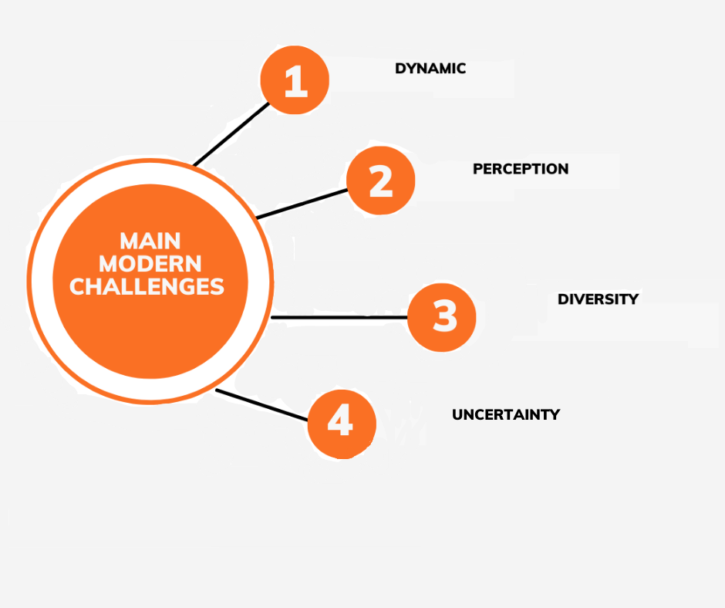

Figure 1: Implementing results in Lean Industry (Singh, 2023)

Providing medical care to a huge number of patients is no doubt a stressful job. When there is going to be a shortage of staff members and the staff embers have to do a lot of work then the level of stress will increase which will be going to lower the performance of the healthcare professionals (McGrane & Olivia McDermott, 2022). The thing I have learned by seeing the workplace environment of healthcare organizations is that there is a need to continuously motivate the workers so that their stress levels can decline and their performance can increase. According to my perspective, healthcare professionals can be motivated by giving monetary and nonmonetary rewards (Yadav & Desai, 2016). The monetary rewards can be incentives, bonuses, paid leaves, paid vacations, etc. Non-monetary rewards include work recognition, flexible working hours, and including healthcare professionals in major decision-making processes. The higher the motivation the lower are going to be the stress levels (Yadav & Desai, 2016). According to McGrane & Olivia McDermott (2022),operational issues are quite common in many healthcare organizations. Usually, operational issues occur due to technical errors and human errors(McGrane & Olivia McDermott, 2022). Healthcare organizations over the years have improved their operations with the help of technology. However, issues in software and other equipment can occur which can affect the operations of the healthcare corporation (Yadav & Desai, 2016). There is no doubt that today many activities of healthcare organizations can be done within minutes thanks to modern techniques and innovations however there is still a need to increase operational efficiency by focusing on the utilization of resources (El-Namrouty & Abushaaban, 2013). Through effective utilization of resources, Healthcare Corporations can improve their efficiency (Lake, et al., 2015). For providing quality care to patients it is important that the latest technologies and treatment methods should be utilized. If the healthcare organization is going to use traditional methods and is not going to focus on patient needs and preferences then such a healthcare organization cannot experience success in the market (Yadav & Desai, 2016). It has been seen, by McGrane & Olivia McDermott (2022), that quality patient care suffers when healthcare professionals are working in a stressful environment and are overburdened due to a shortage of healthcare workers (McGrane & Olivia McDermott, 2022). The quality of patient care also suffers when healthcare organization does not have a major focus on the latest technology or innovation (El-Namrouty & Abushaaban, 2013). The leaders of healthcare organizations can improve quality patient care through strong internal control (Yadav & Desai, 2016). Along with quality patient care the safety of the patients is also very important for healthcare organizations. The healthcare organization must give priority to patient safety so that they can get the best treatment (McDermott & Kevin ODwyer, 2023).

**Lean manufacturing and case studies**

For manufacturing medical devices or products, the importance of regulations on lean six sigma is extremely highly (Yadav & Desai, 2016). The reason behind it is that if the manufactured product is not following the regulation, then it may create problem for health institutes. According to this, the author had provided comprehensive information regarding the effects of medical device regulations. For obtaining results the authors, McGrane & Olivia McDermott (2022), had compared two case studies and compare the transfer of manual manufacturing within a medical device (McGrane & Olivia McDermott, 2022). The main aim of the research to show the required effects of regulatory procedures applied on LSS project implementation and timelines (El-Namrouty & Abushaaban, 2013). Based on this, authors, Yadav & Desai (2016), had also highlighted about the effects of different regulatory procedures and environment. The results of the study were showing the importance of lean six sigma (Yadav & Desai, 2016). However, it is an important first step towards a full understanding about the influence of regulations applied on various operations during manufacturing of medical devices. Lastly, author had also presented some important limitations related to data collection (McGrane & Olivia McDermott, 2022).

In another paper, the author had provided comprehensive information regarding lean manufacturing in the construction site (El-Namrouty & Abushaaban, 2013). However, the author wanted to show the improvement in a construction company by using lean manufacturing and how overall project delivery is enhanced by applying lean six sigma methods combined with BIM for modularizing, design, and manufacturing of different building elements (McDermott & Kevin ODwyer, 2023).

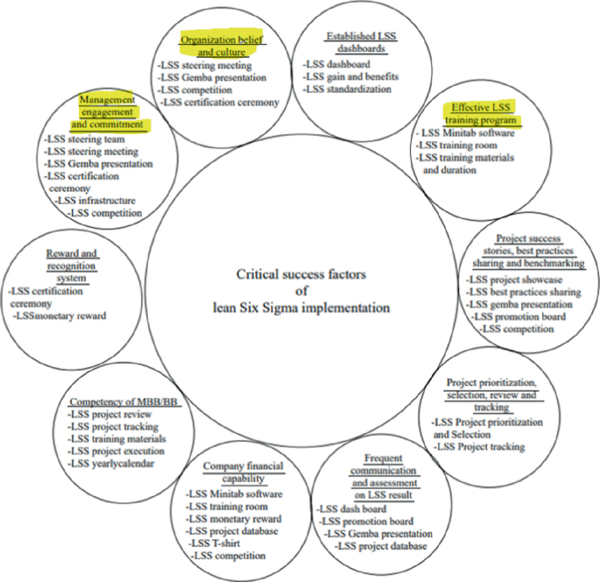

Figure 2: Effectiveness of Implementation of Lean Six Sigma in medical industry (McHugh & Farrell, 2023)

For conducting research, the authors, McDermott & Kevin ODwyer (2023), had used case study approach applied in a construction company involved in using lean six sigma methodology and BIM for identifying non-value add waste used in the construction industry for enhancing sustainability (McDermott & Kevin ODwyer, 2023). The findings were showing that the construction manufacturing company are involved in making various instruments and pipes for the medical field. For this, they are using lead six sigma for standardizing and optimizing productio (Yadav & Desai, 2016). Secondly, the results were showing that the productivity was improved with less waste and less energy was consumed. Also, this technique had minimized the project schedule (McDermott & Kevin ODwyer, 2023). Lastly, author had presented some limitations and implications about the research. Due to this, there is still a need of future research on large scale to obtain the importance of lean six sigma in the manufacturing industry for medical devices (McDermott & Kevin ODwyer, 2023).

According to the research of McDermott & Kevin ODwyer (2023), the importance of lean practices in the medical field is extremely high. However, these lean practices are derived from lean manufacturing principles and they have gained widespread recognition for its ideal potential in improving efficiency, enhance overall performance, and minimize waste in various industries (McDermott & Kevin ODwyer, 2023). Based on the medical device sector, the adoption of lean practices has become increasingly prevalent as various organizations are seeing to streamline processes and improve quality and meeting the evolving demand of the healthcare landscape (McDermott & Kevin ODwyer, 2023). According to these points, the authors, El-Namrouty & Abushaaban (2013), had provided comprehensive information regarding the application of lean principles in the Medical Device sector. It involves the systematic identification and elimination of waste by focusing on improving value for customers (El-Namrouty & Abushaaban, 2013). The author had focused on the adaptability of lean tools like stream mapping, Kanban, and 5S in addressing some important challenges within the complex and highly regulated environment for medical device manufacturing (McDermott & Kevin ODwyer, 2023).

In the past, Irish micro-enterprises were struggling to manufacture a lot of products and facing various challenge. Under these points, author Stuart Nelson et. al, (2022) had provided comprehensive information regarding the evolution of lean deployment in Irish micro-enterprises (Nelson & Olivia McDermott, 2023). For this purpose, the authors, Nelson & Olivia McDermott (2023), had investigated about the main reason behind the lean deployment in Mirco Enterprise and various types of tools used in the medical department. For conducing the research, author had used Qualitative interview method with 22 Micro Enterprises operating in Ireland (Nelson & Olivia McDermott, 2023).

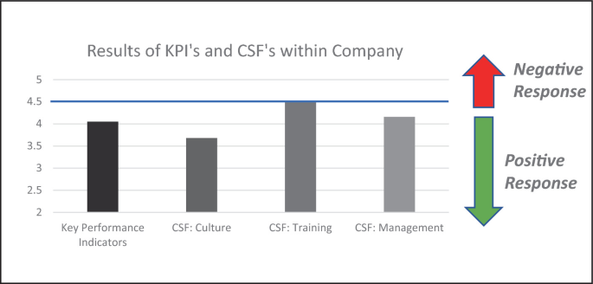

Figure 3: Sustaining the effectiveness of Lean Six Sigma (McHugh & Farrell, 2023)

All these companies were using lean implementation over the past three years. On the other hand, lean is offering a lot of benefits for Micro Enterprises that may similar to those observed in huge-sized enterprises with enhanced productivity, minimized cost and increased quality (Yadav & Desai, 2016). Secondly, the author had found that leadership support in micro-enterprise for the lean implementation is not considered a challenge. Another point highlighted by the authors, (El-Namrouty & Abushaaban (2013), is related to government support, it is an important factor for Lean in Micro Enterprises (El-Namrouty & Abushaaban, 2013). There are some longitudinal studies required on micro enterprises because it will help the research to evolves in such organization over time and employed lean. The results, by Nelson & Olivia McDermott (2023),were showing that government can play an important role for supporting lean manufacturing and increase productivity (Nelson & Olivia McDermott, 2023).

According to Yadav & Desai (2016), there are a lot of studies that highlighted about the positive impacts of lean practices on operational efficiency and quality improvement in the medical device sector (Yadav & Desai, 2016). Based on these facts one research had discussed about how lean implementation can lead towards minimize lead times, enhance overall process efficiency, and improved production flow. Secondly, the main focus of research, by Nelson & Olivia McDermott (2023), is on standardization and continuous improvement may contribute to higher product quality, minimize defects and enhance regulatory compliance (Nelson & Olivia McDermott, 2023).

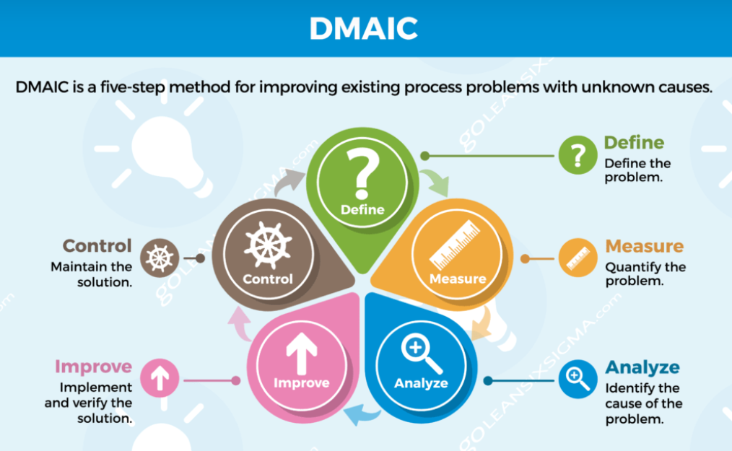

Figure 4: Lean Six Sigma (DMAIC) (goleansixsigma.com, 2023)

Beside the manufacturing of medical devices in Ireland, this is country also working on AgriTech for producing agricultural products (Yadav & Desai, 2016). Moreover, there are a lot of AgriTech companies are present in Ireland that are involved in adapting lean for manufacturing. One author had highlighted these companies in detail. In this paper, the authors, O'Donoghue & Bobby Woods (2023), had assessed and examine the current knowledge of lean within the AgriTech sector and assessing about the main approach used by these companies to stay competitive in the market (O'Donoghue & Bobby Woods, 2023). For this, the author had investigated about the different success factors used for adapting lean in the AgriTech sector of Ireland. For conducting research, author had used quantitative survey taken from 19 companies that worked on adapting lean implementation and showing positive result from the last few years (O'Donoghue & Bobby Woods, 2023). Moreover, the authors, O'Donoghue & Bobby Woods (2023), had also presented some important points regarding the implementation of lean in the AgriTech field. It means that if business wanted to gain more success in the market, then they must adapt Lean manufacturing strategy (O'Donoghue & Bobby Woods, 2023).

# Chapter 3

# Research Methodology

There are generally two types of designs in a research study that can be considered. They are either quantitative or qualitative and sometimes, a mixed-methodology is considered and used that combines both of them. In this case, however, a qualitative design is considered suitable. It involves the utilization of factual information and data obtained through literature reviews, interviews, and even case studies. In this case, a qualitative design is considered and a comprehensive literature review will be used for the acquisition of relevant and credible information. It is worth noting that even though a quantitative design could have been considered, it would not have suited the nature of the research. In addition to it, it would have been inadequate according to the limitations associated with both time and resources. Therefore, instead of a quantitative and a mixed-methodology, a qualitative design has been considered which will rely on literature reviews for acquiring sufficient information. Literature reviews will be carried out using several databases including Google Scholar and Web of Science. Once the relevant and credible studies have been selected, they will be screened to make sure that they are suitable and even eligible to be included in this research. For the purpose of this study, the researcher decided to implement a subjective research strategy, which enabled me to investigate how medical care director’s implemented lean practise in order to effectively manage rising expenses. When trying to determine how something happened, the method of conducting subjective inquiry is the most effective approach to take. The researcher decided to utilize a subjective survey strategy because this method has the potential to supply data that can be used to answer the survey question, and top-down data acquired from members can contribute to the collection of information on propensity. I choose not to use the quantitative research approach, which is based on using material that is true and mathematical in nature.

This article relies on a textual synthesis of predominantly scholarly materials disseminated in the fields of governance studies and pharmaceuticals. The existing literature on the implementation of lean medical services primarily consists of evaluative studies that highlight the benefits of lean practices. Additionally, there are expressive accounts that describe the process of implementing lean in various healthcare settings. However, there is a scarcity of comprehensive research that establishes a clear link between lean implementation and its impact on clinical practise. This study identifies supplementary areas of research for scholars and presents a summary of findings that are pertinent to healthcare professionals interested in implementing lean practises. During the month of February 2020, a thorough investigation was conducted to identify and differentiate significant datasets. The requisite studies to fulfill the companion criteria encompass the following aspects: publication in either English or French, adherence to peer-reviewed standards, observational design, concentration on the utilization of Incline within the medical care domain, and emphasis on its impact on healthcare professionals experiencing bleeding incidents (Parkhi, 2019). The examinations covered in the study exhibited heterogeneity in terms of their composition. The present study involved the coding and grouping of findings. The examination of the articles evaluated focused on assessing the level of quality and systematic rigor in order to establish a certain level of trust in their conclusions.

The thematic approach is used in the research to analyze the literature review by exploring different databases and sources while selecting relevant articles related to the topic of lean manufacturing of medical devices. The researchers were engaged in systematically searching articles related to the project published from 2012 to 2022 from different sources such as Web of Science, Scopus, and Medline. The research questions are answered by searching the topics related to lean NPI and NPD devices (Reinhardt, Oliveira, & Ring, 2020). The research methodology represents that the literature review is analyzed and includes a summary of inclusion criteria that provide information about the results. Future researchers are considered to follow and implement the research findings by getting reviews from the retrieved studies on the specific criteria. In this study, there are different research articles explained and tables are analyzed to get results about the implications of lean manufacturing principles while manufacturing medical devices in Ireland (O’Shanahan, McDermott, & Noonan, 2022).

The systematic review of literature shows that integrating the lean NPI approach in the medical device industry is considered to avoid waste and reduce the cost of traditional manufacturing procedures. Womack et al. discussed the underpinnings of lean NPI and simultaneous developments that were featured alongside the different elements to get an effective authoritative project leadership and controlled communication in the team working. The studies indicate that the cultural perspective and prevalence of CE couldn’t be achieved (Sreedharan & Raju., 2016).

The research project is based on researching the real-world application of lean principles and it is considered best practice to use the case study. The analysis of the case study provides observation about using qualitative and quantitative methods adopted by the researcher fully engaged in the research project and permits get more comprehensive understanding of the investigation problems (Shannon, Trubetskaya, Iqbal, & McDermott., 2023). The case study is based on limited knowledge about the subject therefore the extensive treasure review provided information about the practical examples of lean principles related to the manufacturing of medical devices. Additionally, the examples of case studies help understand the dynamic nature of the specific context to achieve the objectives of developing an understanding of lean principles in manufacturing. For example, based on comparing different lean principles implementation in the manufacturing projects the case study is the most suitable approach to investigate unique critical and relevant subject matters.

The research was undertaken to analyze the two manufacturing organizations as one organization acts as a manufacturer of medical devices and the other one is related to manufacturing electronics. The history represents that the organization started its lean implication journey from the previous five to six years (O’Dwyer, McDermott, Trubetskaya, Noonan, & Rosa.). The case study is based on the collected data primarily from the projects supported with lean principles as in one organization there is an unregulated electronics manufacturer and the other is a highly regulated medical device manufacturer. Both projects were based on similar size and scope but they would be ideal to provide real-world examples of using lean system differences between project timelines in the regulated and unregulated environment. The choice of the methodology of research is based on the validation of the study that provided a margin of error in the conclusion and due to the lack of similar practical case studies comparison in the implementation of lean projects there are some limitations in the research (Filho, Ganga, & Gunasekaran., 2016). However, the comparison of case studies makes sure that there is the possibility to use the lean system and for this purpose, organizations are required to get customer approval to meet the requirements of customers. The size of the project was the second factor that involved the shifting from Thailand to Ireland in the electronics industry and obtaining regulatory approval to move from one manufacturing site to another. The analysis represents that both projects were line transfers and similar in the project type are scale. Regarding the project complexities, both projects were considered copies of each other. The attributes of analysis represent that both manufacturers obtained approval from customers. The one is shifted from Thailand to Ireland and one is shifted from one building to another (Kelly, 2016). Case study one represents that there is no need for regulatory submissions involved in the improving transfer while the case study relates to the medical device manufacturer required getting regulatory submissions in approving the transfer. Both projects are line transfer and copy exactly the manufacturing process.

# Chapter 4

# Results

The research evidence represented the time delay caused by validation and other regulatory requirements in the medical device manufacturing industry required to improve the manufacturing procedure and for this purpose, the organizations are implementing a clean management strategy. For example, the case study about an unregulated industry represented that Lean Six Sigma was implemented as an unregulated manual assembly, and the capability of a process was increased. The project was based on moving the manufacturing procedure for enterprise storage from a low-cost country Thailand to a high-cost country, Ireland (Cawley, Richardson, & Wang., 2011). The shift from high low cost to high cost required improvement in the manufacturing procedure therefore the organizations were required to change their procedures and make sure that the quality is also improved. For this purpose, Lean Six Sigma was implemented and there was no validation of the procedure change and the case study provided information about the unregulated environment (Iyede, Fallon, & Donnellan, 2018). The Lean Six Sigma methods in an unregulated environment represent that the procedure is straightforward and time-consuming however, the analysis of two to three weeks represented that the improvement could be made with the implication of Lean Six Sigma tools during eight weeks (Vaishnavi & Suresh., 2020). The last stage of the manufacturing procedure was the control phase in which different actions were analyzed through Pareto analysis and the process capability was also measured which represents the Lean Six Sigma methods to improve the unregulated manual assembly in the manufacturing procedure. Consequently, there was increased productivity by 25% and Lean Six Sigma methodology made sure that the goals of customers were met while maintaining the commercial success of the organization (Brown, Eatock, Dixon, Meenan, & Anderson., 2008). It was summarized in the research that no need for validation and qualification permits the project to be completed within six months.

Extensive literature also discussed case studies about regulated manual assembly that considered the example of a medical device company comparing its performance with the continuous project and represented that the project took nine months to complete due to additional time and resources required for implementation (Naughton., 2009). The relocation of medical device manufacturing was conducted to add a nearby location and due to the different nature of business, the medical device company developed a contract for manufacturing without any changes and with customer approval. The company followed standard validation activities. If there is any need for book change approval it was outlined in ISO 13485. Due to the increased duration of the improvement phase shrink procedure was shifted to a new building and new design. Technically, the method shift was exactly copied but with the implementation of the Lean Six Sigma method, it was able to identify lean enhancement and optimization of resources (Chugani, Kumar, Garza-Reyes, Rocha-Lona, & Upadhyay., 2017).

As the changes in manufacturing procedure are required therefore the first step is to consider the comprehensive analysis of changes that will happen and the plan was drafted about conducting a contract manufacturer that must be sent to the customers for approval to fulfill the legal and contractual requirements of the agreement. According to the regulatory jurisdiction of Europe, the regulations must be used to improve the quality agreements and execute the manufacturing contracts that are based on a quality management system and have greater availability of records validation (Foley, McDermott, Rosa, & Kharub., 2022). In Europe, the market authorization for manufacturers of medical devices must be clarified to ISO 13485:2015 which fulfills the requirements for quality management systems used by medical device manufacturers. The analysis represents that after analyzing the changes by the customer it is notified by the official authorities and regulatory department to accept or recommend further testing about the regulatory approval. Such approval is based on a simple submission that is required by regulators within 60 days. A new design is required to start new projects under the validation procedure. According to ISO 13485, the organization must revalidate any procedure for reproduction and service provision, and the output could be monitored and measured that define the consequences of deficiencies and delivery of products and services (Duggan, Cormican, & McDermott., 2023). Equipment Operational Qualification (EOQ) serves as the operational check and challenge Equipment Installation Qualification (EIQ) to make sure that the equipment is functioning correctly over time. During the testing, the equipment performs better and this procedure is typically based on five working days to complete. Detailed and time-consuming validation procedures do not take the bulk of time but related to the paperwork for its validation the processed documentation must be updated and based on new equipment in the new location (Nina & Kenneth., 2013).

Lean Six Sigma methodology is based on different types of benefits such as saving money and improving competencies and performance of the manufacturing organization which is helpful to developing long-term relationships with the customers (Molloy., 2011). Therefore, to achieve the performance objective the medical device manufacturing industry is required to use an unregulated environment to achieve the performance objectives. The results of Lean Six Sigma applications in case studies represented that a well-regulated environment represents that regulations may create delays in completing the project or sometimes may create hurdles in getting seamless transitioning of change. The use of Lean Six Sigma in both types of projects is similar but it is not possible that these rules could be implemented in different ways that could affect the project deployment in different ways. The findings and evidence combined in the literature studies concerned the impact of regulations of medical technology and pharmaceutical manufacturers that represent the effect of regulations and validation procedures on the manufacturing process.

# Chapter 5

# Results of Case Studies

## Introduction

The purpose of this chapter of research is to discuss the exploratory study of literature using the case study database that was carried out to analyze the current research work. According to the selected case study, different organizations are operating in Ireland involved in the manufacturing of medical devices. These organizations are based of different sizes including small, medium and large organizations and these organizations implement lean systems according to the suitability of their size and requirements. This approach is helpful to evaluate the manufacturing of medical devices with the implementation of lean tools and principles and the data is collected from the professionals through structured interviews and surveys that provide information about the growing demand for lean for medical technology companies who have exposure to increased waste (Gaberščik, Mitchell, & Fayne., 2020).

## Background

In the current research, the collected case studies based on the data from 20 organizations operating in Ireland. The case studies are based on structured interviews and quantitative data collection from the respondents working in Irish companies and involved in lean programs. The purpose of implementing lean management principles and tools is to obtain the benefits of lean management and overcome the challenges that manufacturing organizations may face due to waste and other types of risk. The lean principle is reviewed based on company size and is directly related to the location of different companies operating in the medical technology industry across Ireland (Schonberger, 2019).

The results represented that lean strategies are helpful for medical technology-based companies to develop and deliver high-quality products and services at a rapid rate without increasing wastage. Lean principles are effective in achieving overall goals and improving the areas of development production and supply chain with efficient strategies. Lean tools and principles are used by the Irish medical technology organizations that participated in the case that this represented that Non-Value Add (NVA) and Value Stream Mapping (VSM) are implemented to generate the actions that are not only helpful to improve the routine functions of organizations but also observe the problems and provide strategies to improve the production flow (Ghadimi, O'Neill, Wang, & Sutherland., 2021). In the context of lean development in case study organizations, there are several objectives for the implication of lean deployment in the medical technology companies that represent the basic benefits of reduction in waste and cost, increased productivity, and overall improvement in the organizational culture. These case studies represent that lean deployment is predominantly introduced in large organization however this concept is helpful for organizations working at any size but due to the nature of the lean system, it is highly beneficial for large organizations. Small and medium organizations also have different benefits of lean deployment but they have to face some constraints that would restrict the ability to implement the initiatives related to lean deployment. The financial and cultural transformation provide benefits of lean deployment quickly therefore focusing on the lean tools at any level is helpful to deliver savings to the bottom line business and is considered a critical part of the business by using a lean system. In the case studies, there are different criteria that are considered difficult to achieve but the implementation of the lean system and industry 4.0 platform could provide greater support to medical technology companies in this transformation (Durakovic, Demir, Abat, & Emek, 2018). The high-performance culture provides a great pillar for achieving superior results innovation and speed however findings about creative ways are helpful to get better and faster results by delivering the products and services that customer wants. The lean deployment implication in medical technology could support the strategic plans.

## Findings

The results of the research discussed the integration of lean principle approach in the medical device industry by examining the case studies of medical enterprises operating in Ireland. The governments of different countries are encouraging and helping the small-scale industries in implication of lean system by providing them financial assistant for getting services from experts (Gruionu & Velmahos, 2015). The information extracted from the case studies provided information about lean businesses in Ireland through structured interviews and quantitative data collected from the participants and the results represented that medical technology organizations provided different reasons for starting the lean journey and these reasons are explained in the table. With the increasing competition in the manufacturing sector, several medical technology companies are using the continuous improvement and change management principle that is helpful to stay competitive in the market (Laureani, Brady, & Antony., 2013). The main reason behind companies implementing continuous improvement and lean management to improve their performance is to increase profitability and create a competitive advantage. These efforts are considered to improve different department performance that provided improvements in the overall performance of the company.

The concept of lean management is mostly based on continuous improvement that is based on enterprise lean manufacturing and lean systems that have objectives to improve the competitiveness and performance of the organization. In the case study, the medical technology organizations that participated in Ireland are funded by the enterprise Ireland (Bamford, Forrester, Dehe, & Leese, 2015). Medical technology organizations lean management principles to improve their production line, improving working progress, standardized procedure, productivity, and quality. In the case study, there are also reasons such as reducing waste and cost saving but all directly implemented would help to obtain the benefits of lean initiatives. The results represented in the table were the benefits of implication of the continuous improvement and lean initiatives across different industries including automobile and pharmaceutical manufacturing.

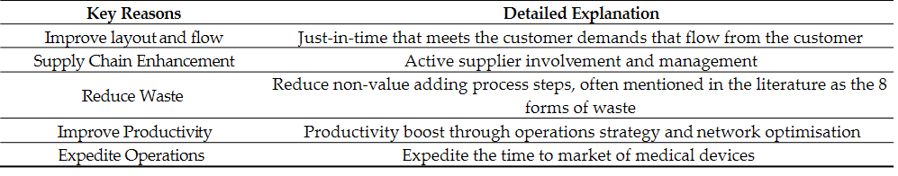 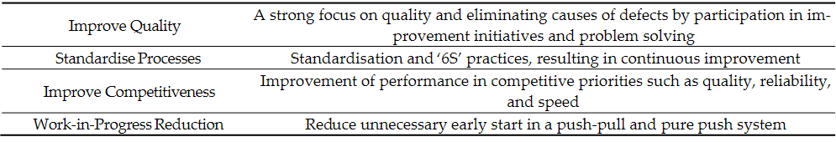

Lean strategies are helpful for medical technology companies to develop and deliver high-quality products and services rapidly with minimized wastage. Lean thinking could be helpful for any industry including automobile pharmaceutical or any type of manufacturing industry therefore medical technology companies could obtain significant benefits and they develop their products by involving lean management in their supply chain. The basic reasons for implementing lean initiatives in medical technology are to improve productivity and to bring the product to the market which makes the company competitive (Davey, Brennan, Meenan, & McAdam, "Innovation in the medical device sector: an open business model approach for high-tech small firms.", 2011). For example, the lean product development process of Toyota is helpful for other companies to consider its ability to beat its competitors in the market by providing better products to meet the requirements of its customers. In case if a medical device manufacturing organization reduces its internal production lead time it will be able to obtain different benefits such as increased investment in development or acquisition and customized benefits (Davey, Brennan, Meenan, & McAdam, "Innovation in the medical device sector: an open business model approach for high-tech small firms.", 2011).

Lean strategies help improve supply chain management as most medical device manufacturing companies are not vertically integrated but with the help of a lean supply chain these organizations could reduce supply chain, and lead time and ensure better quality. The case study represented another reason for the utilization of lean strategies that will provide benefits of obtaining development and more reliable higher quality products that will be based on reduced delivery and lead time cost. Despite of improving the inspection station or increasing the number of such units, a lean medical manufacturing company could use root cause analysis to solve the problems and eliminate the causes of defects (El-Namrouty & Abushaaban, 2013). Continuous flow without interruptions and inventory waste management is a key reason to integrate with the lean initiatives in the medical technology organization. In the continuous layout of the organization, workers could perform efficiently which could add value to their work and easily provide a sense of accomplishment and satisfaction from the work. Organizations are required to improve their work in progress and minimize the production cycle to get optimal results still in the context of quality cost and productivity. The development of key lean parameters in medical technology manufacturing companies can standardize the procedures and services in a complex and vast network of suppliers and customers (Yadav & Desai, 2016).

The lean principle utilized in Irish medical technology organizations participating in the case studies represented that visual management and non-value waste analysis are the key performance indicators that are commonly used by the organizations. It is notable that based on organizational size, there is a difference in the utilization of the lean principle because of the more utilization of the lean principle in large enterprises as compared to smaller and medium enterprises. Small and medium-sized organizations utilized one or two major lean tools however the larger organizations consumed more lean methods (Lawal, et al., 2014). Key performance indicators, visual management, and visual management boards are implemented consistently by the organization as these are the foundational lean tools. The extensive literature review provided information about the important software evaluating the deviation registers in visual management in generating actions that were not implemented in the daily routine but required to get proper observation about the problems and improvements in the production flow.

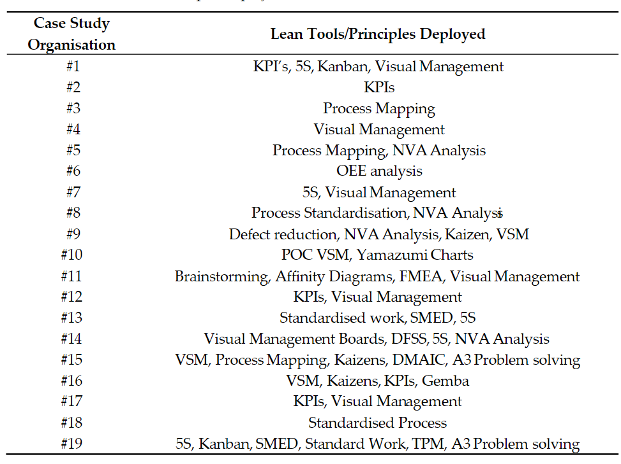

In the above table, there is a discussion about different lean management tools and principles implemented by the organizations participating in the case study. In the literature, there are some less popular tools mentioned and used by the small scale organization. These tools are considered to be less popular among small and medium companies due to the complexities and high cost therefore large organizations prefer to use such lean tools to obtain the benefits on a large scale.

According to Achanga et al., the implementation of lean management with any other productivity improvement initiative is considered to face different challenges such as highlighted in the case study of medical technology-based organizations (Lawal, et al., 2014). These challenges include lack of resources, lack of lean knowledge, lack of training, efforts to create a culture for change, and lack of alignment of metrics with strategic purpose. These organizations are not considered to expand the use of lean initiatives due to such challenges therefore extensive research is conducted that represents the lack of physical and financial resources that may fail in lean development. Organizations are required to be resistant to change if they are more willing to implement lean management principles therefore mostly companies try to change their methods and organizations with limited resources have to struggle more to overcome such challenges. Poor organizational management commitment to lean transformation is considered a major obstacle to obtaining success through lean management. It is part of a broader culture change that includes the commitment of intermediate leaders and senior managers to improve lean efficacy. Management approach in Irish enterprises supports the lean development programs that require focusing on the lack of commitment and support at different levels to obtain sustained lean initiatives by the management (El-Namrouty & Abushaaban, 2013).

The results of case studies represent that the organizations adopted lean management to obtain quantitative and qualitative benefits. In the context of quantitative advantages, there is improved productivity, reduced waste cost, and improved quality however from the perspective of organizational benefits there are different benefits such as increased employee engagement, improved organizational culture for problem-solving education in lean and continuous improvement improved team management and alignment with strategic objectives. Extensive research conducted by the experts demonstrated that the changes in the product type or use of advanced technology in the medical device manufacturing organization could influence the level of success and the lean strategies implemented by the organizations (Yadav & Desai, 2016). The size of the organization also plays a significant role in selecting the lean principles and tools and the result represented that with implications of lean principles, there is increased capacity in the warehouse that is visible in the real-time. A well devised operational plan of lean management helps identify the targets and metrics to represent the successful outcomes and it represented an increase in the gross profit by 200% during six months. The other research represented that with the implication of the lean principle, there is improved staff engagement, increased collaboration, and have better understanding of day-to-day activities among the employees that is helpful to achieve common objectives of overall business. The case study represented that there is a 10% improvement in productivity and also a remarkable improvement in culture. The increased productivity by 20 units per week in one line is helpful to remarkably contribute to the gross profit however the stabilization procedure represented an improvement in productivity by 10 to 15%. The improvement in organizational structure represented that there is a 10 to 20% reduction in scrap that adds value to the inventory of the organization (Bamford, Forrester, Dehe, & Leese, 2015).

# Chapter 5

# Discussion

## Introduction

This section of research is based on compiling the results from all the sections and discussing the findings obtained from literature review case studies surveys interviews etc. The discussion about the results will provide information about the collective findings of research that is helpful to develop insights about the manufacturing of medical devices with the implication of lean principles. The medical technology industry in Ireland is rich and based on a large number of organizations based in Galway, Dublin and Limerick. In Ireland, the medical technology industry is rapidly growing bringing a diverse range of organizations operating at different levels and providing different services to its customers (Duggan, Cormican, & McDermott., 2023). The noticeable difference between the medical technology industry and the other organizations operating in the Pharmaceutical industry is that the manufacturing companies have to face the burden of regulatory requirements and fulfill all these compliances while manufacturing medical devices. Different sizes of medical technology companies are based on the complex nature of networks with suppliers and manufacturing plants therefore different factors require and motivate the companies to implement lean principles and tools. The utilization of lean tools and principles by Irish medical technology companies is considered to work according to the Toyota production system that has objectives to obtain the highest quality in the shortest lead time with lower cost. In this chapter of research, there will be a discussion about the use of clean tools extracted from the extensive literature review and case study results that help review the indication of different experts about the integration of lean tools based on production system goals and organizational culture.

## Discussion of Results

The result section of the research highlighted that the implication of the lean principle is generally considered to do standardized work and improve the quality with the elimination of non-value steps in production. Different tools could be used to minimize the utilization of different resources that are not adding value in the manufacturing procedure which is not only helpful to improve the production procedure but also improve the quality and to minimize the cost of production. Furthermore, changes in the utilization of low lean tools are required to standardize the manufacturing procedures and adopt different methods such as process mapping, Kaizen, and NVA analysis that are required to get substantial manufacturing initiatives in the procedure with proper equipment validations (Farrell, 2022). Such changes could be based at the foundational level that may not affect the product functionality and safety but helpful to overcome the challenges related to regulatory requirements and the majority of changes required to change the layout standardized work and implementation of visual management. There are significant results in the literature review discussing the opportunity to implement similar lean tools in the medical technology industries and organizations operating at different levels. There are larger numbers of small and medium enterprises than the large organizations discussed in the case studies selected for this research.

Lean tools are helpful to implement in a large organization that is understandable and provides significant resources to share the existing resources of the organization. As organizations in Ireland are helping the organizations that are supporting the lean deployment it is not surprising that in such activity there is a major number of small and medium enterprises as these are the companies that have US-based parent companies already entered of implementing lean initiatives (Maware & Modestus Okechukwu Okwu, 2022). The increased support and production in the medical technology organization may create complexities about the patterns of demand shift therefore organizations are required to consider the future growth by adjusting the supplier network according to the selected lean principles. For this purpose, medical technology companies are highly recommended to fulfill the regulatory compliances and regulate the changes in the legislation frequently to overcome the compliance barriers. Consequently, organizations could improve quality and reduce to cost of production which is helpful to maintain an optimal production procedure.

Managing risk is significant in the enterprise it provides the ability to understand define and assesses the implementation of preventive measures to avoid the risk that is the main driver in the risk management frame (Durakovic, Demir, Abat, & Emek, 2018). The relationship between risk identification process and risk management techniques medical technology companies are required to consider different challenges related to the manufacturing of medical device projects. When advanced technology is introduced in the manufacturing process, it is required to perform and make sure that there is no risk in regulatory compliances, and patient and healthcare staff will also not get any adverse impact from using such initiative. For this purpose, organizations are required to get support and approval from the senior management that may be considered a business risk but associating with such compliances is helpful to fulfill the customer's needs without impacting negatively. Advanced digital tools could be used to handle the risk related to the manufacturing of medical devices and manage the supply and demand which is helpful to reduce the pressure on the government authorities and businesses as well. Therefore organizations are considered to overcome the financial challenges and environmental damages to promote a mindset that is based on change initiatives at corporate and individual levels.

Industrial evolution represents an advancement in manufacturing and the use of information technologies to fulfill customized requirements and minimize the risk in manufacturing medical devices required to get wireless connectivity in the medical technology manufacturing and service sectors to improve automation. The discussion about the previous studies on the integration of digital technology in the manufacturing of medical devices identified major barriers such as manufacturing process, medical and professional, medical device reimbursement, material issues, and staff training (Lawal, et al., 2014). Such barriers must be addressed during the training sessions and to improve the opportunities in different areas that require further improvements. Moreover, investigations about different case studies could provide information about exploring new opportunities and unlocking the potential of advanced technology used in the manufacturing of medical devices that is not only beneficial for the engagement of new entrants but also helpful to promote the health care system at an advanced level.

The implication of the lean principle is used to improve regulated and unregulated companies' performance which could overcome the cost of production. It is beneficial for organizations to improve their profit and obtain a high level of customer satisfaction by improving their productivity and supply network. The research represented that the implication of lean initiatives is helpful to achieve an unregulated environment that could overcome the challenges for the organizations and organizations could work without consultation and following the regulations that may create challenges for the manufacturing organizations (Iyede, Fallon, & Donnellan, 2018). For instance, the company shifting from Thailand to Ireland may face difficulty due to lack of regulations fulfillment but at the same time if there is no need to fulfill such compliances as said the company is working under an unregulated environment it is helpful to shift the production and developing the organization at a new location. Such integration is helpful to revalidate the procedure and to influence the implementation process of improvement specifically when the improvements are used to increase the yield and quality by reducing the cost and without any harmful impact on the patients. The academic research demonstrated that there are differences between the implications of lean projects and regulated environment and it should further understand the regulated environment and its influence on the performance of manufacturing organizations.

The medical care industry assumes a critical part in the society, since it is endowed with the significant obligation of safeguarding and upgrading the government assistance of individuals. In recent times, medical care frameworks all over the planet have experienced more complicated and requesting circumstances. Healthcare organizations are under unprecedented pressures due to several factors, including population expansion, aging demographics, the rising frequency of chronic illnesses, and fast technology improvements (Daultani et al., 2015). In general, the fundamental principle of LM or Lean management is that greater efficiency can be attained through consistent improvement aimed at the elimination of waste and maximizing different value-adding activities. It is, however, important to note that the concept has its origins in the car manufacturing or automotive industry. In addition to it, it is also recognized as the TPS or the Toyota Production System and it involves a radical transformation of the typical or traditional methods of mass production. Rather than focusing on the manufacturing of standardized products in large volumes, it focuses on and considers waste elimination as a method for addressing variability and flexibility. Actually, it is quite difficult to retain a straightforward and singular definition of LM. It is generally because of the vast discrepancies among the explanations and definitions used by different researchers. In this case, however, the definition of LM by Radnor et al. is considered. Therefore, LM is specifically a management practice that is based on the idea of consistently improving and optimizing processes either through the reduction of poor work circumstances, process variation, and different non-value adding processes or by raising customer value. In different organizations, LM is recognized to be a solution to waste. In fact, it is considered for addressing unnecessary costs, low flexibility, and even inefficiencies (Allen, 2019).

Even though there are several lean tools, they are designed broadly for assisting firms in comprehending the needs of their customers, identifying and determining different value-adding processes necessary for the manufacturing of desired products and services, consistently refining and improving production processes, reducing overproduction and inventory, and even creating production flow. With time, LM migrated from the industry of car manufacturing to different service firms. Eventually, even public institutions considered and adopted it. Indeed, LM has been associated with several positive outcomes including improved productivity, decreased costs, and enhancement in the quality of services and products. Actually, it has been applied and considered in different settings including ambulatory care clinics, information departments, pharmacy services, and operating rooms among others. In other words, it has been related to better clinical pathways, reduced medical errors, and even decreased waiting times. Currently, there is a lack of studies that actually focus on how lean management practice is capable of affecting projects in the healthcare sector and what challenges it may result in. Therefore, in this research, there will be a focus on the evaluation and determination of the influence of lean management practice on different projects in the healthcare sector (Trubetskaya et al., 2022).

The intricate nature of healthcare systems is further exacerbated by the need to guarantee patient safety and provide treatment of superior quality. The issue of medical mistakes has been recognized as a substantial problem, leading to patient damage and heightened healthcare expenses . The focus of lean management on the standardization of processes and the ongoing pursuit of improvement is in accordance with the objectives of reducing errors and enhancing quality. Hence, it is important to comprehend the degree to which lean methods impact patient safety along with healthcare quality in order to effectively tackle these urgent concerns. Furthermore, the persistent healthcare issues on a worldwide scale, shown by the COVID-19 pandemic, highlight the need for healthcare systems that are adaptable and effective (Hallam & Contreras, 2018). Healthcare initiatives, including the creation of temporary field hospitals and the expedited formulation of vaccine distribution strategies, assume a crucial function in addressing such emergencies. The use of lean management presents a promising framework for augmenting the agility and responsiveness of healthcare initiatives, hence necessitating a comprehensive examination of its suitability and influence inside this particular domain. In addition, it is important to note that healthcare systems in developing as well as developed nations are under significant financial challenges. As a result, the implementation of cost reduction methods has become a crucial worldwide priority. The strategic positioning of lean management as a method for healthcare companies globally is attributed to its potential in optimizing resources and reducing costs. Nevertheless, in order to validate its extensive implementation, it is vital to possess a full comprehension of its influence on the efficiency and cost-effectiveness of healthcare initiatives. The goal of this study is to address the huge information deficiency, ultimately making a significant commitment to the overall accessibility and long haul feasibility of medical care administrations (Allen, 2019).

A significant obstacle is to the assessment of the influence of lean management on patient outcomes. The increase in patient care may be inferred from the decrease in waiting times and medical mistakes. However, accurately measuring the extent of these enhancements remains a challenging endeavor. The establishment of suitable measurements and assessment procedures is crucial in order to properly tackle this situation. The execution of lean administration requires the consolidation of social change as a critical component. A fundamental shift in organizational culture, marked by a commitment to ongoing improvement and employee empowerment, is required for lean principles to be implemented. The fulfillment and support of this social change is a persistent undertaking, requiring a resolute devotion from initiative and a favorable setting within the firm. The allocation of resources is an additional problem, especially in the early phases of implementing lean practices. The allocation of resources towards training, process improvement, and change management might impose a burden on organizational resources. Efficient allocation of resources and strategic budgetary planning are necessary in order to surmount this challenge. Finally, it should be noted that the healthcare industry presents distinct obstacles due to its inherent complexity. Healthcare organizations are obligated to adhere to a range of regulatory mandates, accommodate heterogeneous patient groups, and engage with several stakeholders. The successful implementation of lean concepts within this complex environment requires a customized and situational strategy.

Besides, there has been a predictable vertical pattern in medical services costs throughout numerous years, bringing about impressive weight on both the general population and confidential areas with respect to asset distribution. Without a doubt, the monetary strain is exacerbated by the need to keep up with or work fair and square of care gave to patients (Borges et al., 2019). Given the questionable state of reasonableness and maintainability within the medical services industry, there is a squeezing need to diminish medical services uses and improve functional viability as a way to increment medical care results. Given the previously mentioned concerns, the medical care area has embraced the principles of lean administration, an idea originally acquired from the assembling space and thusly promoted by Toyota during the 1960s. The center standards of lean administration spin on the decrease of waste, upgrade of cycles, and the unending quest for persistent improvement. The possible advantages in the space of medical services are quickly clear. The utilization of lean standards in medical care can possibly lessen failures, upgrade patient satisfaction, enhance asset assignment, and work on the general nature of medical services administrations. The medical care industry has seen a developing predominance of digitalization, portrayed by the inescapable utilization of electronic health records (EHRs) and telemedicine. This development has brought out a variety of obstacles and opportunities. The assertion represents that digitalization facilitates improved accessibility and interchange of data is true; nevertheless, it also introduces complexities in effectively and securely managing substantial volumes of health information (Leite et al., 2020). Lean management, characterized by its emphasis on process optimization, presents a promising opportunity for enhancing the efficiency of digital healthcare operations. Exploring the integration of lean methods into healthcare initiatives is used as a means to use the advantages of digitalization while addressing its associated issues presents a promising area of study. Furthermore, the expeditious rate at which technology improvements are occurring in the healthcare sector requires management practices that are adaptive and imaginative. The flexibility and reactivity of lean management have the potential to support healthcare companies in effectively navigating the dynamic terrain of the industry. Therefore, this study is a crucial contribution towards tackling the current issues faced in healthcare management.

The review of different articles is based on the fact that the implication of lean tools and principles in the medical technology companies did not represent its significant differences to the other industrial sectors but it is considered that the medical device industry adds value with the implication of lean principles. Despite different challenges and difficulties in the implication of lean principles, there are a vast number of available products that are heavily regulated by medical technology industries, and title companies are equipped with better planning for forecasting future market demand (Molloy., 2011). Small and medium organizations involved in the manufacturing of medical devices are examined in the literature and results represented that the organizations integrating with a specific set of lean tools and dependent on advanced technology are considered to develop strategic business plans. Effective planning is helpful to align the matrix with strategic objectives before the selection of specific lean tools and principles and overcome the complexity of maintaining the network of supply and demand in Ireland. The implication of lean management tools is helpful for the practitioner to make strategies based on the experiences of different medical technology companies in Ireland. Moreover, it could penetrate the digital tools in the medical technology industry that provide benefits of improving quality reducing costs, and improving organizational culture and environment overall. The literature review identified the consideration of sustainability in medical technology manufacturing by comparing the case studies related to the implication of lean initiatives in Ireland however its comparison with the European countries could be further investigated.

# Chapter 6

# Conclusion

It is concluded that the research is conducted to analyze the extensive literature review about lean manufacturing tools in the manufacturing medical device industry. For this purpose, the research is based on implementing a mixed research method approach that is helpful to collect the information from authentic resources and it includes the comparison of the case studies operating in similar projects. The research objectives are achieved by analyzing regulatory requirements in lean practices and best practices for the successful implementation of lean manufacturing in the medical device industry. The research is significant to provide information about the impact of clean manufacturing in the medical device manufacturing industry of Ireland because with the implementation of lean principles organizations could achieve multiple benefits such as reduction improved quality and overall positive impact on the performance of the organization. To accomplish the research objective, there is an extensive literature review of the research that discusses the perspective of experts in the medical device industry and their perspectives represent that the implication of the lean principle is helpful to developing organizations operating in any type of industry. There is discussion about different reasons that compel organizations to adopt lean principles as it is possible to improve productivity and support for staff members with the implication of effective strategies.

There is an extensive literature review about the implications of lean manufacturing in the medical device industry but there are further studies that are focusing on long-term sustainability and the implication of lean initiatives that could be researched in future studies. The medical device industry is required to get high-quality manufacturing of devices therefore it is significant for organizations to implement Lean Six Sigma which is helpful to achieve the objectives of improving financial and operational performance by minimizing waste and variations. The results from different studies represented that the implementation of Lean Six Sigma helps obtain a sustainable impact on the manufacturing of medical devices in Ireland. The Industrial Revolution is considered to imply lean initiatives that resulted in improved and sustainable companies operating at different levels. The literature discussed the perspective of the evolution of the medical device industry in Ireland and the fact behind the development of the medical device manufacturing industry is to develop the factors such as skillful workers, government initiatives, and strategic collaborations. The reason behind focusing on the development and innovation in the manufacturing industry is to promote the use of clean initiatives and it is observed that Ireland is home to a diverse range of medical device manufacturing organizations.

The results represent that Lean manufacturing is involved in improving the performance of organizations as the analysis of 2 case studies provided a comparative view in which it is observed that management in the manufacturing of medical devices is helpful to overcome the cost and improve productivity. Medical professionals such as nurses, doctors, technicians, and support workers are considered to promote the use of Lean manufacturing as it is helpful to improve patient care by providing them the devices that could diagnose the level of disease among the patients. Lean initiatives could improve employee engagement, empowerment, and continuous improvement and have a greater influence on the collaborative practices of healthcare professionals in their working activities in the healthcare industry. The popular example of lean initiatives is Toyota which has obtained significant attention in the manufacturing industry on an international level due to the implication of lean initiatives because the organization has considerable focus on the adoption of lean initiatives. Such changes play a significant role in the optimization of resources and provide better care to patients. The findings of research represented that the implication of initiatives is helpful for the organizations to maximize the benefits and minimize the wastage as the case studies comparison provided a view that the lean tools and methodologies in medical device procedures are considered to develop the industry to put best practices to overcome the challenges.

The industry has greater potential to promote the automotive and aerospace industry therefore it is considered to use excellent tools in the medical device industry and increase the profit margins. The regulatory environment is based on multiple challenges for the organizations as it is organizations are required to use the well-established regulatory environment to monitor the structure of road map established by the regulatory bodies. Project management is used to manage different transition phases and regulatory design control. Such methods are implemented by using values frame mapping for the implication of lean tools and techniques that are targeted to reduce the waste from the NPI methods. The use of Lean Six Sigma is helpful to improve both the regulated and unregulated manufacturing process of an organization as it could reduce the production cost and improve profit leading to increased customer satisfaction. The results of the study represent that the implementation of Lean Six Sigma is easily achievable in an unregulated environment however in a regulated environment there are some regulatory compliance that must be fulfilled. At the same time, the analysis of the second case study represents that the shifting procedure from one building to another will take more time due to multiple consultations as the organization is working in a regulated manufacturing environment however the other case study is involved in unregulated manufacturing procedure therefore there is no hard and fast requirements to shift from Thailand to Ireland. The integration with such a system helps improve the manufacturing procedures and improve yield and quality of production.

The implication of scalable procedures in the NPI cycle, there are cultural and educational resources that are required to utilize in the manufacturing of the medical device industry. Regulatory hurdles represented that the expectations for improvement in the medical device industry must be measured from the performance of traditional manufacturing procedures. It could provide suggestions for future research to review and focus on long-term sustainability with the implication of lean initiated through the help of case studies related to the medical device manufacturing industry. This study is valuable for academic research as it has generated deep research about the lean application in the manufacturing of medical devices and could be used to help the lean NPI as a potential factor of Industry 4.0 that could reduce waste and provide cost efficiency in manufacturing procedures. The study helps highlight that the lean initiative could ensure society and public accessibility in the device manufacturing procedure.

# References

Anna Trubetskaya, & Declan Manto, a. O. (2022). A review of lean adoption in the Irish MedTech industry. *Processes*. doi:https://doi.org/10.3390/pr10020391

Antony, J., Sunder M., V., Sreedharan, R., Chakraborty, A., & Gunasekaran, A. (2019). A systematic review of Lean in healthcare: a global prospective. *International Journal of Quality and Reliability Management*, *36*(8), 1370–1391.

Allen, T., T. (2019). Design for Six Sigma. *Introduction to Engineering Statistics and Lean Six Sigma,* pp. 543-550.

Borges, G., A., Tortorella, G., Rossini, M., & Portioli-Staudacher, A. (2019). Lean implementation in healthcare supply chain: a scoping review. *Journal of Health Organization and Management*, *33*(3), 304–322. <https://doi.org/10.1108/JHOM-06-2018-0176/FULL/HTML>

Bamford, D., Forrester, P., Dehe, B., & Leese, R. G. (2015). Partial and iterative lean implementation: two case studies. *International Journal of Operations & Production Management, 35*(5), 702-727.

Brown, A., Eatock, J., Dixon, D., Meenan, B. J., & Anderson., J. (2008). Quality and continuous improvement in medical device manufacturing.". *The TQM Journal, 20*(6), 541-555.

Cawley, O., Richardson, I., & Wang., X. (2011). "Medical device software development-A perspective from a lean manufacturing plant. *In Software Process Improvement and Capability Determination: 11th International Conference, SPICE 2011, Dublin, Ireland, May 30–June 1, 2011. Proceedings 11, pp. 84-96. Springer Berlin Heidelberg,*.

Chien-Yi Huang, ,. D.-C. (2022). A Lean Manufacturing Progress Model and Implementation for SMEs in the Metal Products Industry. *Processes*.

Chugani, N., Kumar, V., Garza-Reyes, J. A., Rocha-Lona, L., & Upadhyay., A. (2017). "Investigating the green impact of Lean, Six Sigma and Lean Six Sigma: A systematic literature review.". *International Journal of Lean Six Sigma, 8*(1), 7-32.

Davey, S. M., Brennan, M., Meenan, B. J., & McAdam, R. (2011). "Innovation in the medical device sector: an open business model approach for high-tech small firms.". *Technology Analysis & Strategic Management, 23*(8), 807-824.

Davey, S. M., Brennan, M., Meenan, B. J., & McAdam, R. (2011). "Innovation in the medical device sector: an open business model approach for high-tech small firms.". *Technology Analysis & Strategic Management, 23*(8), 807-824.

Daultani, Y., Chaudhuri, A., & Kumar, S. (2015). A Decade of Lean in Healthcare: Current State and Future Directions. *Global Business Review*, *16*(6), 1082–1099. https://doi.org/10.1177/0972150915604520

Duggan, J., Cormican, K., & McDermott., O. (2023). Lean implementation: analysis of individual-level factors in a biopharmaceutical organisation.". *International Journal of Lean Six Sigma, 14*(2), 309-334.

Durakovic, B., Demir, R., Abat, K., & Emek, C. (2018). "Lean manufacturing: Trends and implementation issues.". *Periodicals of Engineering and Natural Sciences, 6*(1), 130-143.

El-Namrouty, K. A., & Abushaaban, M. S. (2013). Seven Wastes Elimination Targeted by Lean Manufacturing Case Study Gaza Strip Manufacturing Firms ″. *International Journal of Economics, Finance and Management Sciences, 1*(2), 68-80.

Farrell, A. M. (2022). Sustaining the Effectiveness of Lean Six Sigma Implementation in a Medical Device Company. *In European Lean Educator Conference, pp. 165-183. Cham: Springer International Publishing*.

Filho, M. G., Ganga, G. M., & Gunasekaran., A. (2016). Lean manufacturing in Brazilian small and medium enterprises: implementation and effect on performance.". *International Journal of Production Research, 54*(24), 7523-7545.

Foley, I., McDermott, O., Rosa, A., & Kharub., M. (2022). "Implementation of a Lean 4.0 Project to Reduce Non-Value Add Waste in a Medical Device Company.". *Machines, 10*(12), 1119.

Gaberščik, C., Mitchell, S., & Fayne., A. (2020). Saving lives and saving the planet: the readiness of Ireland’s healthcare manufacturing sector for the circular economy." . *In Sustainable Design and Manufacturing 2020: Proceedings of the 7th International Conference on Sustainable Design and Manufacturing (KES-SDM 2020), pp. 205-214. Singapore: Springer Singapore*.

Ghadimi, P., O'Neill, S., Wang, C., & Sutherland., J. W. (2021). Analysis of enablers on the successful implementation of green manufacturing for Irish SMEs.". *Journal of Manufacturing Technology Management, 32*(1), 85-109.

goleansixsigma.com. (2023). *LEAN SIX SIGMA: STEP BY STEP (DMAIC INFOGRAPHIC).*

Gruionu, G., & Velmahos, G. C. (2015). The lean innovation model for academic medical discovery.". *Technological advances in surgery, trauma and critical care*, 73-80.

Helmold, M., (2020). *Lean management and kaizen.* s.l.:Springer international publishing.

Hussain, M., & Malik, M. (2016). Prioritizing lean management practices in public and private hospitals. *Journal of Health Organization and Management*, *30*(3), 457–474.

Hallam, C., R., A., & Contreras, C. (2018). Lean healthcare: scale, scope and sustainability. *International Journal of Health Care Quality Assurance*, *31*(7), 684–696. <https://doi.org/10.1108/IJHCQA-02-2017-0023/FULL/HTML>

Iyede, R., Fallon, E. F., & Donnellan, P. (2018). "An exploration of the extent of Lean Six Sigma implementation in the West of Ireland.". *International Journal of Lean Six Sigma, 9*(3), 444-462.

Kelly, S. (2016). "Creating a culture of continuous improvement and sustainable management systems at Abbott Diagnostics Longford. *Global Business and Organizational Excellence, 36*(1), 6-24.

Laureani, A., Brady, M., & Antony., J. (2013). Applications of lean six sigma in an Irish hospital. *Leadership in health services, 26*(4), 322-337.

Lawal, A. K., Rotter, T., Kinsman, L., Sari, N., Harrison, L., Jeffery, C., et al. (2014). "Lean management in health care: definition, concepts, methodology and effects reported (systematic review protocol).". *Systematic reviews, 3*(1), 1-6.

Leite, Higor, Bateman, N., & Radnor, Z. (2020). Beyond the ostensible: an exploration of barriers to lean implementation and sustainability in healthcare. *Production Planning and Control*, *31*(1), 1–18. https://doi.org/10.1080/09537287.2019.1623426

Lake, D., Baerg, K. & Paslawski, T. (2015). *Teamwork, Leadership and Communication: Collaboration Basics for Health Professionals.*

Maware, C., & Modestus Okechukwu Okwu, a. O. (2022). A systematic literature review of lean manufacturing implementation in manufacturing-based sectors of the developing and developed countries. *International Journal of Lean Six Sigma*.

McDermott, O., & Kevin ODwyer, J. N. (2023). The development of a lean six sigma and BIM framework for enhancing off-site manufacturing. *International Journal of Lean Six Sigma*.

McHugh, A., & Farrell., F. (2022). Sustaining the Effectiveness of Lean Six Sigma Implementation in a Medical Device Company.". *In European Lean Educator Conference, pp. 165-183. Cham: Springer International Publishing.*

McKernan, D., & McDermott., O. (2022). "Challenges Facing Medical Device Companies in Ireland and Why Operational Excellence is not Enough.". *In European Lean Educator Conference, pp. 204-217. Cham: Springer International Publishing.*

McDermott, O., & Kevin ODwyer, J. N. (2023). The development of a lean six sigma and BIM framework for enhancing off-site manufacturing. *International Journal of Lean Six Sigma*. doi:https://doi.org/10.1108/IJLSS-02-2023-0020

McGrane, V., & Olivia McDermott, A. T. (2022). The effect of medical device regulations on deploying a lean six sigma project. *Processes*.

Molloy., G. (2011). The role of customer centricity in medical device innovation: an Irish Perspective.".

McHugh, A., & Farrell, F. (2023). Sustaining the effectiveness of lean six sigma implementation in a medical device company. In IFIP advances in information and communication technology (pp. 165–183). https://doi.org/10.1007/978-3-031-25741-4_15

Naughton., K. (2009). A study of Irish medical device companies best practice new product development tools and methodologies.". *PhD diss*.

Nelson, S., & Olivia McDermott, B. W. (2023). An evaluation of Lean deployment in Irish micro-enterprises. *Total Quality Management & Business Excellence*.

Nina, R., & Kenneth., J. (2013). "Medical Device Assembly Yield Improvement: Application of Quality Foundations.". *Manufacturing Engineering* .

O’Dwyer, K., McDermott, O., Trubetskaya, A., Noonan, J., & Rosa., A. (n.d.). The Development of a Lean Six Sigma & Business Information Modelling Framework for Enhancing Off-site Manufacturing.".

O’Shanahan, J., McDermott, O., & Noonan, J. (2022). Design for Lean Six Sigma Application in a Family Run Multi-generational Micro Enterprise–A Case Study. *In European Lean Educator Conference, pp. 318-328. Cham: Springer International Publishing,*.

O'Donoghue, K., & Bobby Woods, S. M. (2023). Adoption of Lean by AgriTech Companies in Ireland. *In 2023 IEEE International Symposium on Technology and Society (ISTAS),*.

Parkhi, S. S. (2019). Lean management practices in healthcare sector: a literature review. *Benchmarking*, *26*(4), 1275–1289.

Reinhardt, I. C., Oliveira, J. C., & Ring, D. T. (2020). "Current perspectives on the development of industry 4.0 in the pharmaceutical sector.". *Journal of Industrial Information Integration, 18*, 100131.

Schonberger, R. J. (2019). "The disintegration of lean manufacturing and lean management.". *Business Horizons, 62*(3), 359-371.

Singh, S. (2023, August 23). What is Lean Industry 4.0 and How to Implement it for Results? Retrieved from https://otofacto.tech/insights/what-is-lean-industry-4-0-and-how-to-implement-it-for-results/

Shannon, N., Trubetskaya, A., Iqbal, J., & McDermott., O. (2023). "A total productive maintenance & reliability framework for an active pharmaceutical ingredient plant utilising design for Lean Six Sigma.". *Heliyon, 9*(10).

Sreedharan, V. R., & Raju., R. J. (2016). "A systematic literature review of Lean Six Sigma in different industries.". *International Journal of Lean Six Sigma, 7*(4), 430-466.

Trubetskaya, A., & Olivia McDermott, a. P. (2023). Implementing a customised Lean Six Sigma methodology at a compound animal feed manufacturer in Ireland. *International Journal of Lean Six Sigma*.

Trubetskaya, A., & Olivia McDermott, a. S. (n.d.). Implementation of an ISO 50001 energy management system using Lean Six Sigma in an Irish dairy: a case study. *The TQM Journal 35*.

Vaishnavi, V., & Suresh., M. (2020). Modelling of readiness factors for the implementation of Lean Six Sigma in healthcare organizations.". *International Journal of Lean Six Sigma, 11*(4), 597-633.

Yadav, G., & Desai, T. N. (2016). "Lean Six Sigma: a categorized review of the literature.". *International Journal of Lean Six Sigma, 7*(1), 2-24.